Գավառի ավագ դպրոց

Հերթական ատեստավորման ենթակա ուսուցիչների վերապատրաստման
դասընթաց
Խումբ 1
Հետազոտական աշխատանք
Հետազոտող ուսուցիչ՝ Անահիտ Մխեյան
Ղեկավար՝ Նելլի Գափոյան
Թեմա՝ Միջառարկայական կապերի կիրառման ազդեցությունը սովորողների մետաճանաչողության վրա

Գավառ 2023
Բովանդակություն
- Ներածություն ․․․․․․․․․․․․․․․․․․․․․․․․․․․․․․․․․․․․․․․․․․․․․․․․․․․․․․․․․․․․․․․․․․․․․․․․․․․․․․․․․․․․․․․․ 3
- Միջառարկայական կապ ստեղծելու նպատակ ․․․․․․․․․․․․․․․․․․․․․․․․․․․․․․․․․․․․․․․․․․․․․․․․ 4
- Միջառարկայական կապերի դերն ու նշանակությունը ուսումնական գործընթացում ․․․․․․․․․․․․․․․․․․․․․․․․․․․․․․․․․․․․․․․․․․․․․․․․․․․․․․․․․․․․․․․․․․․․․․․․․․․․․․․․․․․․․․․․․․․․․․․․․․․․․․․․․․ ․․ 4
- Մաթեմատիկայի և ֆիզիկայի կապը ․․․․․․․․․․․․․․․․․․․․․․․․․․․․․․․․․․․․․․․․․․․․․․․․․․․․․․․․․․․․ 7
- Մաթեմատիկայի և քիմիայի կապը ․․․․․․․․․․․․․․․․․․․․․․․․․․․․․․․․․․․․․․․․․․․․․․․․․․․․․․․․․․․․․ 8
- Մաթեմատիկայի և աշխարհագրության կամ բնագիտության կապը ․․․․․․․․․․․․․․․․․․․․․ 9
- Մաթեմատիկայի և կենսաբանության կապը ․․․․․․․․․․․․․․․․․․․․․․․․․․․․․․․․․․․․․․․․․․․․․․․․․․ 10
- Մաթեմատիկայի և մայրենի լեզվի կապը ․․․․․․․․․․․․․․․․․․․․․․․․․․․․․․․․․․․․․․․․․․․․․․․․․․․․․․ 11
- Մաթեմատիկան երաժտության մեջ ․․․․․․․․․․․․․․․․․․․․․․․․․․․․․․․․․․․․․․․․․․․․․․․․․․․․․․․․․․․ 12
- Մաթեմատիկան ճարտարապետության մեջ ․․․․․․․․․․․․․․․․․․․․․․․․․․․․․․․․․․․․․․․․․․․․․․․․ ․ 13
- Մաթեմատիկան գրականության մեջ ․․․․․․․․․․․․․․․․․․․․․․․․․․․․․․․․․․․․․․․․․․․․․․․․․․․․․․․․․․․ 13
- Մաթեմատիկան ինֆորմատիկայի մեջ ․․․․․․․․․․․․․․․․․․․․․․․․․․․․․․․․․․․․․․․․․․․․․․․․․․․․․․․․ 15
- Մաթեմատիկան շախմատի մեջ ․․․․․․․․․․․․․․․․․․․․․․․․․․․․․․․․․․․․․․․․․․․․․․․․․․․․․․․․․․․․․․․․․․ 16
- Ուսուցման արդյունքները ․․․․․․․․․․․․․․․․․․․․․․․․․․․․․․․․․․․․․․․․․․․․․․․․․․․․․․․․․․․․․․․․․․․․․․․․․ 19
- Վերլուծություն․․․․․․․․․․․․․․․․․․․․․․․․․․․․․․․․․․․․․․․․․․․․․․․․․․․․․․․․․․․․․․․․․․․․․․․․․․․․․․․․․․․․․․․ 21
- Եզրակացություն ․․․․․․․․․․․․․․․․․․․․․․․․․․․․․․․․․․․․․․․․․․․․․․․․․․․․․․․․․․․․․․․․․․․․․․․․․․․․․․․․․․․ 22
- Գրականություն ․․․․․․․․․․․․․․․․․․․․․․․․․․․․․․․․․․․․․․․․․․․․․․․․․․․․․․․․․․․․․․․․․․․․․․․․․․․․․․․․․․․․․․ 23

Ներածություն
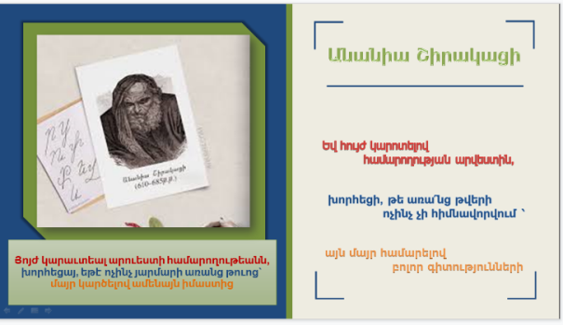
Մենք բոլորս գիտենք, որ բոլոր առարկաները ինչ-որ կերպ փոխկապակցված են, կամ նույն թեման աշակերտները սովորում են տարբեր առարկաներից, տարբեր դիտարկումներով։ Այստեղ շատ կարևոր է միջառարկայական կապերի դերը, ուսուցչի սահուն ներկայացումը, որպեսզի աշակերտները հասկանան, թե ինչը՝ որտե՞ղ և ո՞նց կիրառել։ Ուսուցիչը պետք է պատկերացում կազմի և գաղափար ունենա դպրոցում դասավանդվող բոլոր առարկաների մասին, որպեսզի կարողանա հմտորեն կազմակերպել և վարել միասնացած դասեր, ստեղծել միջառարկայական կապեր, այդ կերպ պայմաններ ստեղծելով դասավանդման ընթացքում աշակերտների կողմից բազմաբաղադրիչ գիտելիքների ձեռքբերման համար։ Որպեսզի սովորելու գործընթացն առավել հնարավոր լինի, կրթության համակարգը պետք է փորձի գրավել աշակերտների ուշադրությունը։ Աշակերտները պետք է հասկանան, որ մաթեմատիկան բոլոր բնագիտական առարկաների <<թագուհին է>>, և որ մաթեմատիկա սովորում են նաև բնագիտական առարկաները հասկանալու և հեշտ ընկալելու համար։ Ինչպես ասել է իտալացի աստղագետ եւ ֆիզիկոս Գալիլեո Գալիլեյը « Մաթեմատիկան այն լեզուն է, որով Աստված գրել է տիեզերքը» :
Ուսուցման գործընթացում իրենցից առավել հետաքրքրություն են ներկայացնում միջառարկայական և ներառարկայական կապերը: Բնության երևույթները մի միասնական ամբողջություն են կազմում և դրանք հասկանալու համար էլ պետք է միասնական մոտեցում ցուցաբերել, այսինքն՝ դրանք ուսումնասիրել այլ երևույթների հետ իրենց բազմակողմանի կապերի մեջ: Այսօր միջառարկայական կապերի խնդիրը արդիական է դարձել. հնարավորություն ենք ունենում հետաքրքիր ինտեգրված դասեր մշակել և իրականացնել:
Միջառարկայական կապ ստեղծելու նպատակն է՝
- Սովորողի մոտ ձևավորել հետաքրքրություն մյուս առարկաների նկատմամբ
- Ցույց տալ դասավանդվող առարկայի կարևորությունը՝ մյուս առարկաները սովորելու գործում
- Խթանել սովորելուն և ամրապնդել սովորածը
- Նպաստել, որպեսզի կարողանա կիրառել սովորածը առօրյա կյանքում
- Թեմայի ուսումնասիրության ժամանակի խնայողություն ունենալ` ցանկանալով օգտվել մեկից ավելի առարկաների պատրաստի բովանդակությունից
- Առարկայի դասավանդման ժամանակ պրոբլեմադիր և զարգացնող ուսուցում իրականացնել
- Զարգացնել ուշադրությունը և այլն։
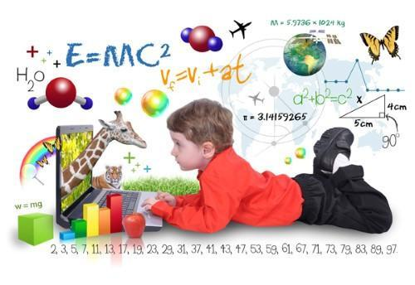
Միջառարկայական կապերի դերն ու նշանակությունը ուսումնական գործընթացում
Մեր ժամանակներում առաջնակարգ նշանակություն է ստանում առարկաների և գիտությունների համագործակցությունը` միջառարկայական կապերը: Ուսուցման գործընթացում կարևոր տեղ պետք է հատկացնել միջառարկայական կապերին, որոնք ուսուցման հաջողության անհրաժեշտ պայմաններից են: Միջառարկայական կապերի մասին Յ.Ա.Կոմենսկին իր «Մեծ դիդակտիկա» աշխատությունում նշում է, որ ուսումնական առարկաների փոխկապակցված ուսուցումը երեխաներին սովորեցնում է բացահայտել ուսումնասիրվող առարկաների և երևույթների միջև եղած կապերը. «Ամեն ինչ ամրապնդել բանականության հիմունքներով նշանակում է ամեն ինչ սովորել՝ մատնացույց անելով պատճառները, այսինքն՝ ոչ միայն ցույց տալ, թե ինչպես է այս կամ այն բանը տեղի ունենում, այլ նաև ցույց տալ, թե ինչու դա այլ կերպ լինել չի կարող: Չէ՞ որ իմանալ որևէ բան նշանակում է իրը ճանաչել իր փոխկապակցվածության մեջ»:
Միջառարկայական կապ ստեղծելու կարևոր մեթոդ է այլ առարկայի ուսուցչի հետ փոխհամագործակցումը։ Հաճախ միջառարկայական կապ ստեղծելու նպատակով ուսուցիչները ինտեգրված դասեր են վարում, յուրաքանչյուր ուսուցիչ ներկայացնում է դասի իր մասը։ Միջառարկայական ուսուցումը բնութագրվում է բազմամասնագիտական ​​գիտելիքների ինտեգրմամբ կենտրոնական ծրագրի թեմայի կամ ուշադրության կենտրոնում: Կրկնվող միջառարկայական մտքի ենթարկվելով՝ սովորողները զարգացնում են ավելի առաջադեմ իմացաբանական համոզմունքներ, զարգացնում են քննադատական ​​մտածողության կարողությունները և մետաճանաչողական հմտությունները և տարբեր առարկաներից բխող հեռանկարների միջև փոխհարաբերությունների ըմբռնում: Դիտարկվող ուսուցման արդյունքի կառուցվածքի մեր հարմարեցումը ցույց է տալիս միջառարկայական գիտելիքների ինտեգրման փուլերը և բացատրում սովորողների ինտելեկտուալ գործունեության համապատասխան օրինաչափությունները՝ մեկ առարկայի տեղեկատվության ձեռքբերումից մինչև միջառարկայական խնդիրների փոխանցումը, այլ թեմաներ, կամ խնդիրներ դիտարկելիս։
Ի տարբերություն ուսումնական ծրագրերի, որոնք ակամայից խրախուսում են մասնագիտացված տեղեկատվության առանձին հատվածների անգիրը, միջառարկայական կրթությունը հեշտությամբ նպաստում է կառուցվածքային գիտելիքների զարգացմանը։ Դեկլարատիվ գիտելիքը (փաստացի տեղեկատվություն) և պրոցեդուրա (գործընթացի վրա հիմնված տեղեկատվություն), որոնք օգտագործվում են խնդիրների լուծման կամ քայլ առ քայլ առաջադրանքների կատարման համար, հիմք են հանդիսանում կառուցվածքային գիտելիքների ձեռքբերման համար:
Միջառարկայական մոտեցումները նաև հանգեցնում են գիտելիքների բարդ, ներքին կազմակերպման: Գոլդսմիթը և Քրեյգերը սահմանեցին տեղեկատվության այս կազմակերպությունը որպես «գիտելիքի կառուցվածք»՝ բոլոր հարակից տեսանկյունների, հասկացությունների, գաղափարների և հետազոտության մեթոդների ներքինացված շրջանակ, որը կազմում է գիտելիքի տիրույթը և տալիս է դրա իմաստը: Գիտելիքի կառուցվածքները հայտնի են մի քանի պիտակներ՝ «սխեմաներ», «մտավոր մոդելներ» կամ «հայեցակարգային շրջանակներ»; բայց չնայած տերմինաբանության տարբերություններին, այս կառուցվածքները բոլորն էլ ներկայացնում են ճանաչողական գիտության կենտրոնական դրույթը: Դրույթն այն է, որ գիտելիքի կազմակերպումն առնվազն կարևոր է, քանի որ կուտակված գիտելիքների քանակն օգնում է անհատին որոշել, թե երբ և ինչպես է մի շարք դեկլարատիվ փաստեր կիրառվում որոշակի իրավիճակում: Թեև գիտելիքի կառուցվածքները բացառապես միջառարկայական երևույթներ չեն, գիտելիքի տիրույթում իմաստալից կապեր ստեղծելու կարողությունը զգալիորեն նպաստում է միջդիսցիպլինար տեսանկյունների ներդրմանը: Օրինակ՝ օպերայից, ջազից, վեպերից և քարոզներից տեղյակ ուսանողները, հավանաբար, կպատկերացնեն դրանք կապող իմաստալից օրինաչափություններ և ընդլայնեն այս պատկերացումները նոր հանդիպող իրադարձությունների և գաղափարների մեջ: Կենտրոնանալով խնդրի կամ հիմնական թեմայի վրա՝ միջառարկայական մոտեցումները խրախուսում են ուսանողներին ընկալել կապերը թվացյալ ոչ առնչվող տիրույթների միջև՝ դրանով իսկ հեշտացնելով գիտելիքների կազմակերպման անհատականացված գործընթացը: Օրինակ, միջդիսցիպլինար հումանիտար դասընթացի ուսանողներին կարող են խրախուսել ստեղծել ընկալողական կապեր այնպիսի ոլորտների միջև, ինչպիսիք են էթիկան, դրամատուրգը կամ նույնիսկ առևտրային դիզայնի հանրաճանաչ մշակութային չափումները: Դրեսելը (1958) առաջարկել է, որ միջառարկայական ծրագրերը ուսանողներին տրամադրում են մի զգացում, թե ինչպես կարելի է կազմակերպել բազմամասնագիտական ​​գիտելիքները և առաջարկել անհատի կարգապահության ինտեգրման գործընթացի մեկնարկի կետ: Երբ ուսանողները յուրացնում են նոր ինտեգրված հասկացությունները նախնական գիտելիքների և փորձի հետ, նրանք ավելի բարդ կապեր են ստեղծում դեկլարատիվ փաստերի միջև, որոնք, ի վերջո, կարող են կանխատեսել գիտելիքի ընդլայմանը։ Ըստ Ռանդելի, որպես հետևանք, երբ բարձր որակավորում ունեցող անձինք բախվում են գործնական խնդրի հետ, նրանք հակված են հիշել ինտեգրված գիտելիքների ավելի մեծ բլոկներ, այլ ոչ թե տեղեկատվության փոքր ենթախմբեր: Ընդհանուր առմամբ, կառուցվածքային գիտելիքների ավելի բարձր մակարդակները կապված են բարելավված խնդիրների հետ. լուծելու և գիտելիքների փոխանցման հմտություններ, ինչպես նաև սովորած տեղեկատվության հիշողության, պահպանման և ըմբռնման բարձրացում: Ավելի բարձր, քան ավանդական, մեկ թեմայի մոտեցումները, միջառարկայական ուսուցումը խթանում է խնդրի վրա հիմնված տեղեկատվության ինտեգրումը, որը համահունչ է ավելի բարդ գիտելիքների կառուցվածքներին:

Դիտարկենք մի քանի օրինակներ, թե ինչու՞ պետք է սովորել մաթեմատիկա, և ինչպես է այն կապված մյուս առարկաների հետ։

Մաթեմատիկայի և ֆիզիկայի կապը
Օրինակ մեծությունները և նրանց չափման միավորները մենք սովորում ենք, որ կարողանանք կիրառել ֆիզիկայում՝ մարմինները, երևույթները ուսումնասիրելիս։
Մաթեմատիկայի կարևորությունը ֆիզիկայի իրավիճակները լուծելու համար, ներկայացվում է հասկանալով, որ մաթեմատիկան լեզուն է էմպիրիկ օրենքների ձևավորման համար:
Մաթեմատիկայի մի մեծ մասը որոշվում է օբյեկտների միջեւ փոխհարաբերությունները հասկանալու և որոշելու միջոցով: Հետևաբար, ֆիզիկան մաթեմատիկայի հատուկ օրինակ է:
Ընդհանրապես համարվել է շատ մտերիմ փոխհարաբերություն, որոշ մաթեմատիկոսներ այս գիտությունը նկարագրել են որպես «ֆիզիկայի համար անհրաժեշտ գործիք», իսկ ֆիզիկան ՝ որպես «մաթեմատիկայի ոգեշնչման և գիտելիքների հարուստ աղբյուր»:
Հաշվի առնելով, որ մաթեմատիկան բնության լեզուն է, կարելի է գտնել Պյութագորասի գաղափարներում. Համոզմունք, որ «թվերը կառավարում են աշխարհը» և որ «ամեն ինչ համար է»:
Այս գաղափարները արտահայտեց նաև Գալիլեո Գալիլեյը. «Բնության գիրքը գրված է մաթեմատիկական լեզվով»:
Մարդկության պատմության մեջ երկար ժամանակ է պահանջվել, մինչ ինչ-որ մեկը հայտնաբերեց, որ մաթեմատիկան օգտակար և նույնիսկ կենսական է բնությունը հասկանալու համար:
Արիստոտելը կարծում էր, որ բնության խորքերը երբեք չեն կարող նկարագրվել մաթեմատիկայի վերացական պարզությամբ:
Գալիլեյը ճանաչեց և օգտագործեց մաթեմատիկայի ուժը բնության ուսումնասիրության մեջ ՝ թույլ տալով, որ իր հայտնագործությունները սկսեն ժամանակակից գիտության ծնունդը:
Ֆիզիկոսը, բնական երեւույթներն ուսումնասիրելիս, ունի առաջընթացի երկու մեթոդ.
- փորձի և դիտարկման մեթոդը
- մաթեմատիկական հիմնավորման մեթոդը:
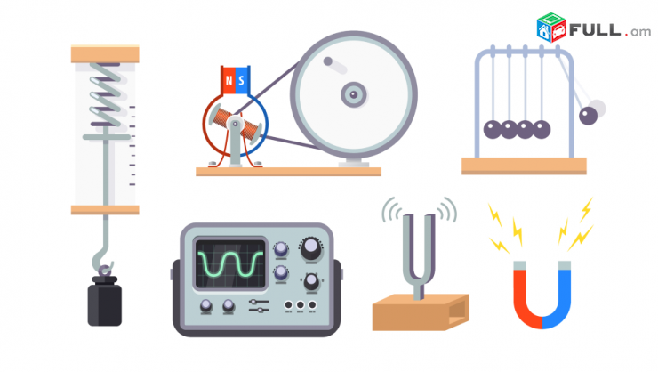
Մաթեմատիկայի և քիմիայի կապը
Համեմատություններ կազմել և հաշվել պետք է լավ իմանանք, քանի որ քիմիայում շատ ենք կիրառում, ռեակցաներ կազմել և հաշվել, Մենդելեևի այուսակից օգտվել ևս մեզ կօգնի մաթեմատիկան։
Չափումներ կատարելը, ծավալային վերլուծություն կատարելը, ջերմաստիճանը, խտությունը որոշելը և այլն, այն ամենը, ինչ հնարավոր չէ անել առանց մաթեմատիկայի:
Մաթեմատիկական քիմիայի հիմնական մոդելներն են մոլեկուլային գրաֆիկը և տոպոլոգիական ինդեքսը:
Մաթեմատիկական քիմիայում մոլեկուլային գրաֆիկը կառուցվածքային բանաձևի ներկայացումն է գրաֆի տեսության տեսանկյունից։

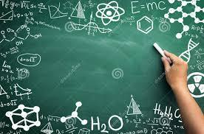
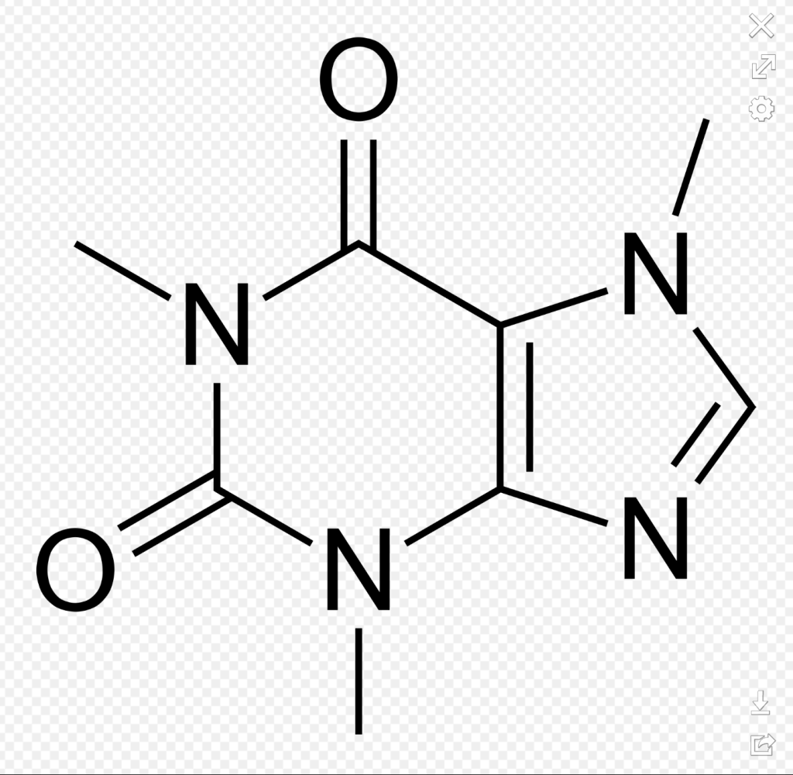
Մաթեմատիկայի և աշխարհագրության կամ բնագիտության կապը
Հետաքրքիր է, երբ վերցնենք կամայական քարտեզ ամպայաման կնկատենք անկյունում գրված մասշտաբ:Առանց մասշտաբի գաղափարի ընկալման չի պարզաբանվի ցանկացած քարտեզ:Ցանկացած երկու քաղաքների հեռավորությունը իմանալու համար, պետք է իմանալ մասշտաբը: Կամ ինչպես կարելի է նկարագրել աշխարհագրական որևէ տարածք կամ տեղ, չիմանալով կոորդինատները:
<<Մասշտաբ>> թեման աշակերտները սովորում են նախ բնագիտություն առարկայից, ապա մաթեմատիկայից։ Առավել ուշիմ աշակերտը անմիջապես մաթեմատիկայի դասաժամին հիշում է, որ բառն իրենց ծանոթ է, ապա ուսուցչի մի փոքր հուշումով շատերը վերհիշում են ի՞նչ է մասշտաբը։ Բայց, բնագիտության դասաժամին աշակերտները մասշտաբն ընկալում են, որպես Երկրի մակերևույթի որևէ տեղանքի փոքրացված մոդել, հասկանում են, թե ինչ է իրենից ներկայացնում քարտեզը, իսկ մաթեմատիկայից տվյալ թեմայի նպատակն է, որ աշակերտները կարողանան ինքնուրույն հաշվումներ կատարել, որևէ տեղանքի գծագիր ներկայացնեն տրված մասշտաբով, հասկանան, որ որոշակի մասշտաբով կարող ենք ոչ միայն փոքրացնել երկու կետերի հեռավորությունը, այլ նաև փոքր մանրակներ նախագծելիս դրանք մի քանի անգամ մեծացնել։
Մաթեմատիկական աշխարհագրություն, ֆիզիկական աշխարհագրության բաժին, որտեղ տրվում են տեղեկություններ Երկրի (որպես մոլորակ) ձևի, մեծության և շարժման մասին։ Քննարկում է աշխարհագրական կոորդինատների նկատմամբ Երկրի յուրաքանչյուր կետի դիրքի որոշման և դրա հետ կապված ժամանակի հաշվարկումների եղանակները։ Լայն կիրառություն ունի քարտեզագրության և գեոդեզիայի մեջ:
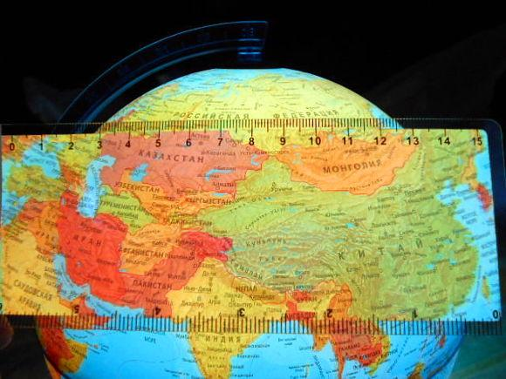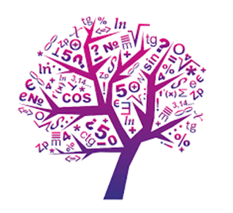
Մաթեմատիկայի և կենսաբանության կապը
Կեսաբանության դասընթացում հանդիպում են կմախքային տարրերի բազմազան ձևեր ՝ եռանկյուն, քառակուսի, շեղանկյուն, վեցանկյուն և այլն։ Բնական վեցանկյուն կառույցների մեջ առավել հիասքանչ ստեղծագործությունը մեղվահացի մեղվաբջիջն է։ Այստեղ ևս հանդիպում են խնդիրներ, որոնք պահանջում են մաթեմատիկական հաշվարկ։
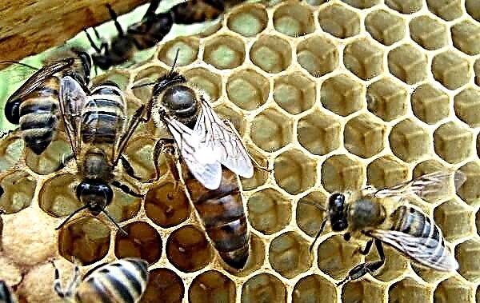
Մենդելեևի առաջին օրենքից բխում է, որ առանձնանում են դոմինանտ և ռեցեսիվ ֆենոտիպեր։ Որի հաշվարկներին նպաստում է մաթեմատիկան: Կան դոմինանտության երևույթի տարբեր օրինակներ։ Վառ օրինակ է այն, որ դեղին և կանաչ ոլոռների խաչասերման արդյունքում առաջացած նոր ոլոռը դեղին է։
Մաթեմատիկայի և մայրենի լեզվի կապը
Մայրենի լեզուն փոխկապակցված է բոլոր առարկաների, այդ թվում մաթեմատիկայի հետ։
Մաթեմատիկայի դասերին արդյոք մի՞շտ է, որ աշակերտները կապակցված նախադասություններ են օգտագործում: Երբեմն աշակերտները թեորեմները, սահմանումները կամ ցանկացած դատողություններ ձևակերպելիս ճիշտ չեն կազմում համաձայնությունը նախադասության անդամների միջև, ճիշտ չեն կարողանում օգտագործել կետադրությունը, որից և փոփոխվում է նախադասության, թեորեմի, սահմանման իմաստը:
Այս դեպքում կարևորում եմ ուսումնական նյութի շարադրանքում տրամաբանական կառուցվածքներին համարժեք լեզվական արտահայտչամիջոցների ճշգրտման և հստակեցման խնդրի լուծումը: Աշակերտների գրավոր աշխատանքներում հանդիպում ենք այնպիսի մտքեր, որտեղ աշակերտը չի կարողանում տարբերել հատկությունը հայտանիշից կամ սահմանումը թեորեմից:
Ես, նաև, կառանձնացնեի թվերի գրությունը, դասակարգումը, այբուբենի տառերը իրենց համապատասխան թվերով և այլն։

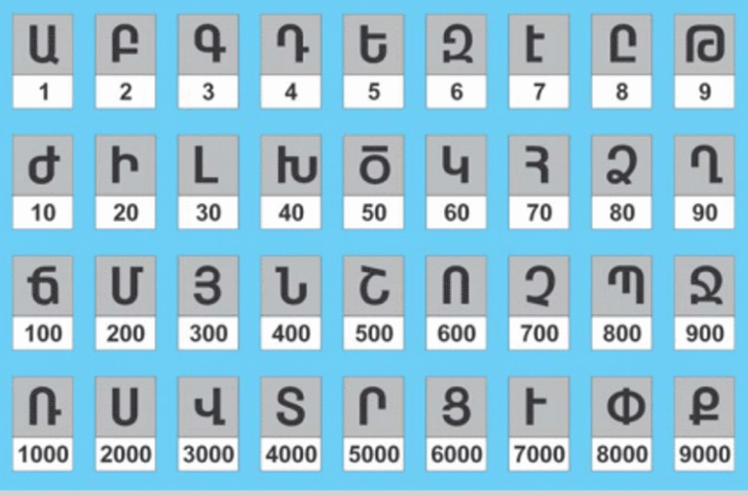

Մաթեմատիկան երաժտության մեջ
Որքան զարմանալի է, երաժիշտ դառնալու համար պետք է մաթենատիկա լավ իմանալ, որպեսզի նոտաները տարբերակել։
Պյութագորասն առաջինն էր, որ նկատեց հնչյունների ներդաշնակության և կոտորակային թվերի կապը: Նա պարզեց որ լարի1/2-ի արձակած ձայնը համահունչ է ամբողջ լարի արձակած ձայնին: Այդ ձայներն ունեն տարբեր բարձրություններ և նրանց միջև գտնվող ձայների միջակայքը կոչվում է օկտավա

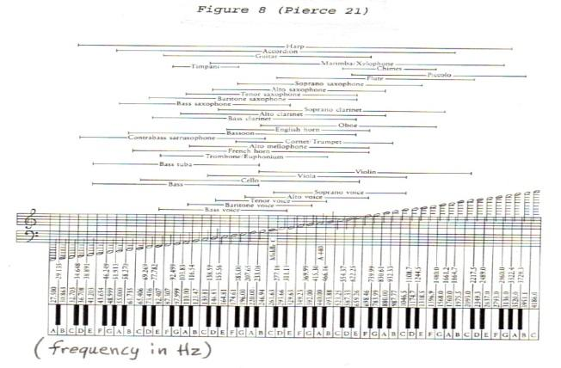
Մաթեմատիկան ճարտարապետության մեջ
Դեռևս հին ժամանակներում մեծագույն մտածողները հասկանում էին, որ բնության շատ երևույթներ կառավարում են օրենքով, որոնք կարող ներգրավել մաթեմատիկորեն: Մասնավորապես հին Հունաստանի մեծ փիլիսոփա Պլատոնը հենց համաչափության մեջ էր տեսնում այդ հրաշալի գաղափարի դրսևորումը: Բնությունը հագեցած է համաչափ տեսք ունեցող էակներով և առարկաներով, որոնց համաչափությունը մարդու կողմից վաղուց ի վեր ընկալվել է որպես գեղեցկության ուղեկից: Դարերի ընթացքում կենսագործվել է համաչափության գաղափարը տարբեր ժողովուրդների կերպարվեստում և ճարտարապետության մեջ:

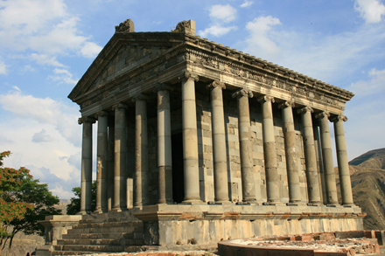

Մաթեմատիկան գրականության մեջ
Թվաբանությունը դուրս է պոեզիայի ոլորտից, բանաստեղծը պետք է մտածի հանրահաշվորեն:

Եվ գիծը նաև հուսախաբությա՜ն,
Որ մեր կյանքի հետ
Վա՜յ թե հենց կազմի զուգահեռություն.
Իսկ զուգահեռը զուգահեռի հետ
Չի՛ հատվում կարծեմ...

ՙԱռաջադրանք համայն աշխարհի հաշվիչ մեքենաներին և ճշգրիտ սարքերին
Պարույր Սևակ
Հաշվո՛ւմ եք, հաշվո՜ւմ...
Հաշվեցե՛ք հապա,
Թե ի՞նչ ալիքով, քանի՞ վայրկյանում
Եվ քանի՞ գրամ արյուն է հոսում աղջըկա սրտից
Դեպի ամոթխած այտերը նրա՝
Առաջ բերելով ա՛յն բռնկումը ջերմամիջուկային,
Որ մինչև այսօր, միամտաբա՜ր, շիկնանք ենք կոչել։
Եվ կոսմիկական ճառագայթների ի՞նչ հոսք է անցնում
Մեր մթնոլորտված աչքերի միջով,
Երբ հանկարծակի նրանք դիպչում են ուրիշ աչքերի,
Եվ այս փոխադարձ ճառագայթումը
Վտանգավո՞ր է մեր սրտի համար,
Թե՞ օգտակար է։

Հաշվո՛ւմ եք, հաշվո՜ւմ... 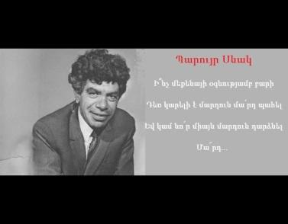
https://www.youtube.com/watch?app=desktop&v=jFvmqe7Yf74

Մաթեմատիկան ինֆորմատիկայի մեջ

Ինֆորմատիկա-մաթեմատիկա միջառարակայական կապը խիստ հետաքրքիր է ու հեռանկարային՝ որպես սովորողների աշխարհայացը ձևավորող գործոն։ Դրա համար կան մի շարք հիմնավորումներ․
1. Արդի ժամանակաշրջանը բնութագրվում է որպես անցում դեպի տեղեկատվական հասարակություն, որում աշխարհի պատկերը կառուցվում է նյութ-էներգիա-տեղեկատվություն եռամիասնության մեջ։
2. Կրթության առաջնահերթ խնդիրը այդ հասարակության մեջ կյանքին նախապատրաստությունն է և, հետևաբար, ամբողջական աշխարհահայացի ձևավորումը՝ հիմնված իրականության նկատմամբ տեղեկատվական մոտեցման վրա։
3. Հանրակրթության մեջ առանձնահատուկ դեր է վերապահվում ինֆորմատիկային, և, առաջին հերթին, նրա տեսական տարրերին։
4. Ինֆորմատիկան դառնում է ինտեգրող առարկա, նրանով միավորվում են բնագիտական ու հումանիտար գիտություններից ստացվող գիտելիքները:

Ինֆորմատիկան, որի տեսական մասը ծագել է մաթեմատիկայից, մեծապես օգտվում է վերջինիս ապարատից: Ինարատիկայի դպրոցական դասընթացի շատ թեմաներ կարելի է համարել զուտ մաթեմատիկական՝ թվարկության համակարգեր, հավանականությունների տեսության և մաթեմատիկական վիճակագրության տարրեր, մաթեմատիկական տրամաբանության հիմունքներ, գրաֆների տեսություն, մաթեմատիկական մոդելավորում և այլն: Այդ թեմաների ուսուցումը չի մտնում մաթեմատիկայի դպրոցական դասընթացի ծրագրում, բայց, ինչպես փորձն է ցույց տալիս, դրանց ծանոթ աշակերտները մաթեմատիկայի մասին ավելի համակարգված գիտելիքներ ունեն և ավելի հեշտ են յուրացնում նոր գաղափարներ, թեորեմներ:
Ելնելով ասվածից, կարծում ենք, որ կարելի է առանձնացնել ինֆորմատիկա-մաթեմատիկա՝ միջառարկայական կապերի հետևյալ հնարավորությունները․
1. Ինֆորմատիկայի դասընթացում մաթեմատիկայի առարկայական բովանդակության օգտագործումը: Օրինակներ․
ա) ալգորիթմի հասկացության ուսուցումը` մաթեմատիկական խնդիրների հիման վրա,
բ) տեղեկատվական տեխնոլոգիաների ուսուցումը /ի մասնավորի՝ տեքստային կամ գրաֆիկական խմբագրիչների մաթեմատիկական բովանդակության նյութերի օգնությամբ,
գ) ծրագրավորման լեզուների ուսուցում՝ մաթեմատիկական նյութի օգտագործմամբ (օրինակ, Լոգո լեզուն հարմար է երկրաչափական օբյեկտների գծագրման ու հետազոտման համար):
2․ Ինֆորմատիկայի ծրագրի մեջ ոչ ավանդական բովանդակային նյութերի ընդգրկումը: Օրինակ՝ տրամաբանության հիմունքներ և բազմությունների տեսություն։
3. Մաթեմատիկայի դասընթացում փաստերի ներառում, որոնք անհրաժեշտ են ինֆորմատիկա ուսուցանելու համար, բայց՝ կամ բացակայում են մաթե մատիկայի ծրագրում և կամ էլ բավարար խորությամբ չեն ներկայացված {օրինակ՝ տրամաբանության հանրահաշվի օրենքները):
4. Մաթեմատիկայի դասավանդումը՝ տեղեկատվական տեխնոլոգիաների կիրառմամբ։
5. Մաթեմատիկայի դասընթացում հասկացությունների ուսումնասիրում, որոնք ներմուծվում են ինֆորմատիկայում (օրինակ՝ մաթեմատիկական մոդելները որպես ինֆորմացիոն մոդելների տեսակներ):
6. Կոնկրետ մաթեմատիկական հարցի ուսուցման զուգակցումը խնդրի տեխնոլոգիական ու տեխնիկական հիմնավորված ու համարժեք լուծման ընտրության հետ։
Լուծումներ՝ մոտավոր մեթոդներով և օպտիմալացման խնդիրներ՝ բազմաթիվ փոփոխականներով ու սահմանափակումներով։
Թվարկենք մի քանի ընդհանրացնող մաթեմատիկա-ինֆորմատիկա դասերի թեմաներ, որոնք կարող են սովորողների մոտ մեծ հետաքրքրություն առաջացնել. «Հավասարումների համակարգերի լուծումը գրաֆիկական եղանակով Excel միջավայրում», «Քառակուսային հավասարումների լուծում», «Ֆունկցիաների գրաֆիկներ և նրանց հատկությունները», «Ցիկլային ալգորիթմներ: Եռանկյունաչափական ֆունկցիաների գրաֆիկների կառուցում», «Տնտեսագիտական բովանդակության խնդիրների լուծում» և այլն:

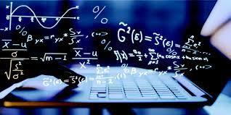

Մաթեմատիկան շախմատի մեջ
Այժմ՝ շախմատի և մաթեմատիկայի մի քանի կապերի և դրանցից որոշները ուսուցման պրոցեսում օգտագործելու հնարավորությունների մասին:
Շախմատի և մաթեմատիկայի ամենամեծ ընդհանրությունը՝ նրանց վերացական և աքսիոմատիկ բնույթի մեջ է: Ինչպես մաթեմատիկան է վերացարկվում քննարկվող օբյեկտների կոնկրետությունից և ուսումնասիրում է հարաբերություններ ու ձևեր մաքուր տեսքով, այնպես էլ շախմատի համար միևնույն է, թե ինչից է պատրաստված սեղանը, ինչ են իրենցից ներկայացնում դաշտերը և ինչ տեսք ունեն խաղաքարերը։ Ինչպես շախմատային քայլը, այնպես էլ մաթեմատիկական ապացուցման յուրաքանչյուր փուլը պետք է համապատասխանեն ընդունված կանոնների (օրենքների)։ Շախմատային խնդրի լուծումը պետք է լինի նույնքան համոզիչ, որքան մաթեմատիկական թեորեմի ապացույցը: Այսպիսով, ողջ շախմատայի խաղը տեղավորվում է մաթեմատիկայի շրջանակներում, իրենից ներկայացնելով հաշվարկների մի տարատեսակ։ Արդեն իսկ կան ծրագրեր, որոնք կարողանում են ցույց տալ յուրաքանչյուր դիրքից բխող լավագույն քայլերը. այդ ալգորիթմը կարող է գտնվել, օրինակ, բոլոր հնարավոր քայլերի դիտարկման ճանապարհով, ինչը կարող է անել միայն համակարգիչը: Դրա համար ներմուծվում է գնահատող ֆունկցիա, որը յուրաքանչյուր դիրքին տալիս է որոշակի նիշ (գնահատական): Կարելի է, օրինակ, գումարել սպիտակ և սև ֆիգուրների ուժերը և որպես դիրքի գնահատական՝ վերցնել նրանց տարբերությունը: Դիտարկելով բոլոր տարբերակները՝ տրված խորությամբ՝ համակարգիչը առաջարկում է լավագույն քայլը։
Կա մի խնդիր, որը տանում է մաթեմատիկական ֆոլկլորի խորքերը՝ կախված հենց շախմատի ծննդի հետ, դա շախմատային տախտակի վրա ցորենի հատիկների հայտնի խնդիրն է։ Բայց կա մի ուրիշ պատմական վարկած ևս, թե ինչպես է շախմատը ծնվել մոգական քառակուսիներից:
ո-րդ կարգի մոգական (կամ կախարդական) քառակուսի է կոչվում ոxո չափերով աղյուսակը, որը լրացված է 1-ից ո2 բոլոր ամբողջ թվերով և ունի հետևյալ հատկանիշը, յուրաքանչյուր տողի, սյունակի և երկու գլխավոր անկյունագծերի` թվերի գումարը նույնն է: 8-րդ կարգ մոգական քառակուսու (շախմատի) համար այն 260 է։ Խնդիրը կարելի է քննարկել ինֆորմատիկայի ժամին ևս՝ այն առաջադրելով այսպես. Կազմել ծրագիր, որը կարողանա 1-64 թվերը դասավորել 8x8 մատրիցում այնպես, որ ստացվի մոգական քառակուսի: Այս դեպքում կստեղծվի մաթեմատիկա –շախմատ՝ինֆորմատիկա կապ։
Ասվածին կարելի է տալ նաև գեղարվեստական երանգավորում: Թվերի յուրօրինակ խճանկարը մոգական քառակուսիներին տալիս է արվեստի ստեղծագործության հրաշալի ուժ։ Իզուր չէ, որ գերմանացի նշանավոր նկարիչ Ա․ Դյուրերը, այնքան էր հմայված մոգական քառակուսիներով, որ դրանցից մեկը արտացոլեց իր հանրահայտ «Մելանխոլիա» փորագրության մեջ:
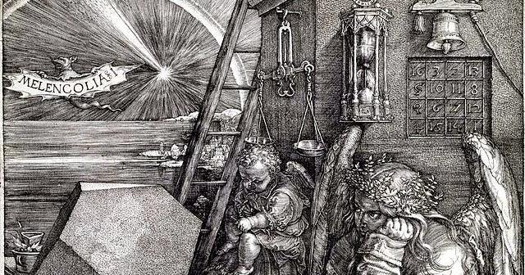
Շախմատային մաթեմատիկան իր մեջ կարող է ներառել տարաբնույթ խնդիրներ (շախմատային տախտակի երկրաչափության, խաղաքարերի երթերի, ֆիգուրների տեղաբաշխման և ուժի, շախմատիստների խաղի ուժը գնահատող տարբեր գործակիցների մասին և այլն): Շախմատը նաև հիանալի մոդել է մաթեմատիկական լուծում պահանջող ժամանակակից շատ խնդիրների համար։ Շախմատային խաղի դիսկրետությունը համապատասխանում է համակարգչի թվային բնույթին և ընդհանրության եզրեր է ստեղծում խաղերի տեսության, նաև՝ հավանականությունների տեսության, մեծ համակարգերի տեսության հետ: Մարդը, հաճախ չկարողանալով վարքի ու գործունեության ճշգրիտ կանոններ ձևակերպել, գործում է ինտուիտիվ, ենթագիտակցորեն ընտրելով ճիշտ որոշումը: Անհրաժեշտությունը՝ համակարգիչներին սովորեցնել» խնդիրներ լուծել համանման կերպով, հանգեցրին կիբեռնետիկայի նոր բաժնի` էվրիստիկ ծրագրավորման ստեղծմանը։ Դրա իմաստն այն է, որ բոլոր հնարավոր տարբերակների դիտարկման փոխարեն համակարգիչը «սովորի» վերլուծել ամենահեռանկարայինները միայն ժամանակակից համակարգիչները կարողանում են նաև «ինքնակրթվել» օգտագործել արդեն խաղացված պարտիաների փորձը: Այդպիսի շախմատային ավտոմատը կարող է դառնալ ինքնակրթվող էլեկտրոնային ուղեղի՝ արհեստական բանականությամբ ռոբոտի նախահիմք:
Մաթեմատիկայի դպրոցական դասընթացում կարելի է առանձնացնել ինֆորմատիկայի և շախմատի հետ առնչվող այնպիսի կապեր, որոնք պայմանականորեն կոչվում են «հետաքրքրաշարժ խնդիրներ»։
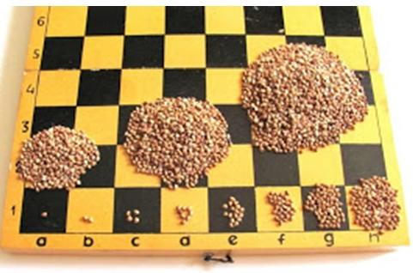

Ուսուցման արդյունքները
Ճանաչողական տեսաբանների աճող թիվը համաձայն է, որ «գիտելիքի ձեռքբերման և կատարողականի միջև կապը շատ ոլորտներում պահանջում է ոչ միայն դեկլարատիվ փաստեր, այլ՝ շրջանակ կամ կապերի մի շարք, որը հանգեցնում է հասկանալու, թե երբ և ինչպես են մի շարք գործողություններ կիրառվում տվյալ իրավիճակում» (Դորսեյ):
Այս փաստը հաշվի առնելով ես՝ մաթեմատիակայի մյուս ուսուցիչների հետ պատրաստեցի պաստառ <<Մաթեմատիկան ամենուր է>> վերնագրով։
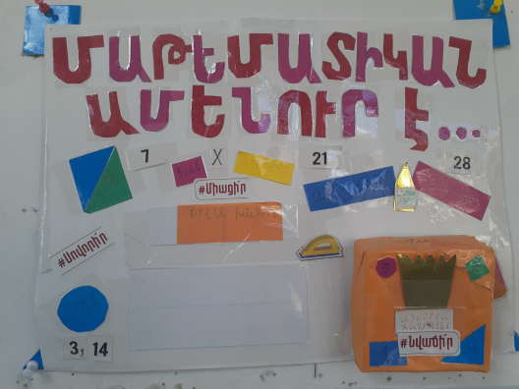
Ամեն օր առաջարկում էինք խնդիր, տարբեր դասարանների համար, որը պետք է աշակերտները լուծեին և լուծումները տեղադրեին համապատասխան արկղիկում։ Սկզբից խնդիրը լուծում էր մեկ, երկու աշակերտ, այն էլ մի քանի օրում։ Այդ ընթացքում մենք կազմակերպեցինք դաս-միջոցառում մաթեմատիկայից, որին մասնակցում էին տարբեր դասարաններից 50-ից ավել աշակերտ։ Այստեղ աշակերտները ներկայացնում էին մաթեմատիկայի կիրառությունը տարբեր ոլորտներում և կապը տարբեր առարկաների հետ։ Միջոցառումից հետո ավելացավ խնդիրներ լուծող աշակերտների թիվը և մենք խնդիր էինք առաջադրում ամեն օր։

Մեր միջոցառման նկարներից
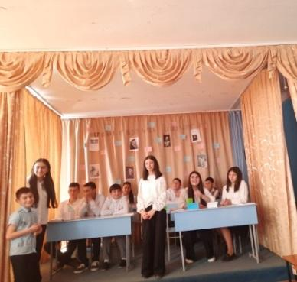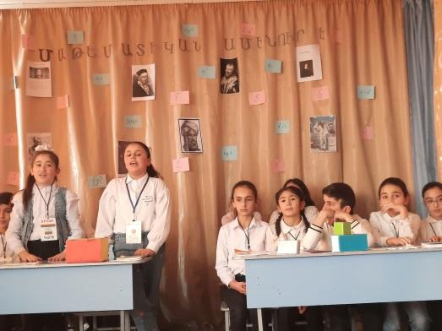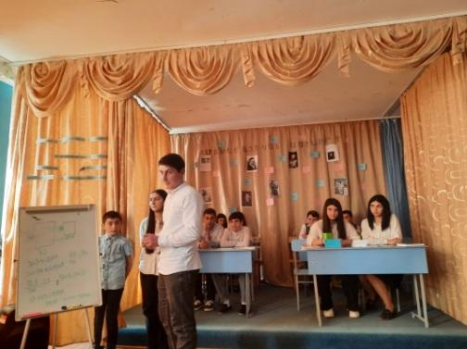

Այստեղ ամեն ինչ կառուցված էր մաթեմատիկայի շուրջ։ Աշակերտները խոսում էին մաթեմատիկայի լեզվով՝ երգի, պարի, կառուցումների, տրամաբանական խնդիրների, բանաստեղծությունների, պատմական փաստերի, հանելուկների, ճարտարապետության միջոցով։ Աշակերտները և ներկաները եկան այն համոզմունքին, ու կա մի գիտություն, առանց որի անհնար է մնացածների համար: Դա մաթեմատիկան է, որի գաղափարները, դատողությունները և խորհրդանիշները ծառայում են որպես լեզու, նրանով գրում, խոսում, մտածում են մյուս գիտությունները: Այն բացատրում է դժվարին երևույթների օրինաչափությունները, կանխագուշակում և մեծ ճշգրտությամբ նախօրոք նկարագրում երևույթների ընթացքը (Սոբոլև):
Այսպես, մարտի 23-ին Կարմիրգյուղի N1 միջնակարգ դպրոցում մաթեմատիկայի տոն էր: 5-12 րդ դասարանների ավելի քան 50 աշակերտներ մասնակցեցին << Մաթեմատիկան ամենուր է>> խորագիրը կրող համադպրոցական միջոցառմանը, որը կազմակերպել էին մաթեմատիկայի ուսուցիչները: Աշակերտները ներկայացրին մաթեմատիկայի գեղեցկությունը, կարևորությունը և անհրաժեշտությունը մեր կյանքում, մեր առօրյայում: Աշակերտները <<Մաթեմատիկա>> գիտությունը ներկայացրին և՛ հայոց, և՛ ռուսաց լեզուներով՝ աֆորիզմների, երգերի, պարի, բանաստեղծությունների, տրամաբանական խնդիրների միջոցով, ներկայացրին մաթեմատիկայի կիրառությունը և մաթեմատիկայի <<գույները>>։ Միջոցառման նպատակն էր ցուցադրել մաթեմատիկայի անսահման գեղեցկությունը, մաթեմատիկայի կապը բոլոր առարկաների և ոլորտների հետ, խթանել սաների տրամաբանական մտածողության զարգացումը, զարգացնել մաթեմատիկայի նկատմամբ ունեցած սերը և հետաքրքրությունը, նաև նպաստել տարբեր դասարանի աշակերտների միջև ընկերական կապի ձևավորմանը։
Մաթեմատիկան ամենուր է,
Ինչ-որ անես նա քեզ հյուր է,
Չես էլ կարող, որքան ուզես,
Առանց մաթեմատիկայի մեկ քայլ անես։

Առարկաների սերտաճումը մեկ համապատասխան թեմայի շուրջ նպաստում է ինտելեկտուալ հասունացմանը՝ յուրաքանչյուր առարկայի կողմից ներկայացված հեռանկարների վերլուծության, համեմատության և հակադրման միջոցով:

Վերլուծություն
Ինչպես արդեն վերը նշեցի, <<Մաթեմատիկան ամենուր է>> միջոցառումը ավելացրեց աշակերտների հետաքրքրասիրությունը մաթեմատիկա առարկայի նկատմամբ, խթանեց նրանց մետաճանաչողականության զարգացմանը։ Հատուկ ուշադրություն ենք դարձրել այն երևույթի վրա, որ աշակերտները տարբեր առարկաների դասերի ընթացքում առավել հաճախ են նշում կապերը տվյալ առարկայի և մաթեմատիկայի միջև ու հիմնավորում հասկացությունները:
Եթե մինչ միջոցառումը 50 աշակերտից միայն հինգն էր գտնում մաթեմատիկա այլ առարկաների թեմաների մեջ, հիմա արդեն բնագիտական առարկաների, և ոչ միայն, ուսուցիչները փաստում են, որ աշակերտների մոտ 80℅- ը անմիջապես գտնում է մաթեմատիկայի և տվյալ առարկայի կապը։
Ստորև կներկայացնեմ մաթեմատիկայի և տվյալ առարկայի միջև կապ գտնող աշակերտների թվի փոփոխությունը (աճը) միջոցառումից առաջ և հետո՝ աղյուսակի և դիագրամի միջոցով։ Նշեմ նաև, որ հետազոտությունը կատարված է 50 աշակերտի շրջանակում։
Մաթեմատիկայի և տվյալ առարկայի միջև կապ գտնող աշակերտներ
Միջոցառումից առաջ | Միջոցառումից հետո
5 | 40
10℅ | 80℅

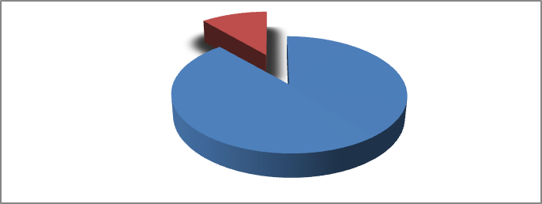

Եզրակացություն
Այսպիսով, իմ հետազոտությունը ցույց տվեց, որ մաթեմատիկա կա ինչպես դպրոցական բոլոր առարկաների մեջ, այնպես էլ բոլոր ոլորտներում՝ շինարարություն, սպորտ, տեղեկատվական տեխնոլոգիա, մշակույթ և այլն։ Որպեսզի աշակերտները հասկանան մաթեմատիկայի դերն ու նշանակությունը առօրյա կյանքում, պետք է ուսուցիչը միշտ ցույց տա տվյալ թեմայի՝ այլ առարկաների հետ կապը, այսինքն՝ ստեղծի միջառարկայան կապ՝ համագործակցելով գործընկերների հետ։
Ամեն անգամ, երբ մենք զբաղվում ենք որևէ ճանաչողական կամ վարքային առաջադրանքով, մեր ուղեղն օգտագործում է մտավոր ներկայացում կամ գիտելիքների կառուցվածք, որը համապատասխանում է այդ առաջադրանքին վերաբերող բառին, պատկերին կամ այլ տեղեկատվության: Փորձը նպաստում է այդ ներկայացուցչության հետագա հարստացմանն ու կառուցվածքին:

Օգտագործված գրականություն

Մաքիել Կեստրա << Metacognition as a prerequisite for interdisciplinary integration>>

Կառուցողական կրթության հիմունքները և մեթոդները (ձեռնարկ ուսուցիչների համար), Ե.- 2004., էջ 42

Иванов, В.Г. <<Междисциплинарные связи в образовательном процессе>> / В.Г. Иванов, Т.А. Иванова // Среднее профессиональное образование. – 2000. - № 12. – С. 44 – 46

Զարուհի Պետրոսյան, Զավեն Պետրոսյան: Ինֆորմատիկա, <<Հետաքրքրաշարժ խնդիրներ>>

Զարուհի Պետրոսյան, Զավեն Պետրոսյան: Հետաքրքրաշարժ խնդիրներ շախմատային թեմաներով «Մաթեմատիկան դպրոցում», 2,2013թ., էջ 51-57:

<<Course Information and communication technologies in teaching mathematics from the project to realization the Bologna process in science and mathematics, higher education in North Eastern Europe>>. Tendencies,perspectives and problems. Joensuun Yliopisto, 2006, p149-156.

