

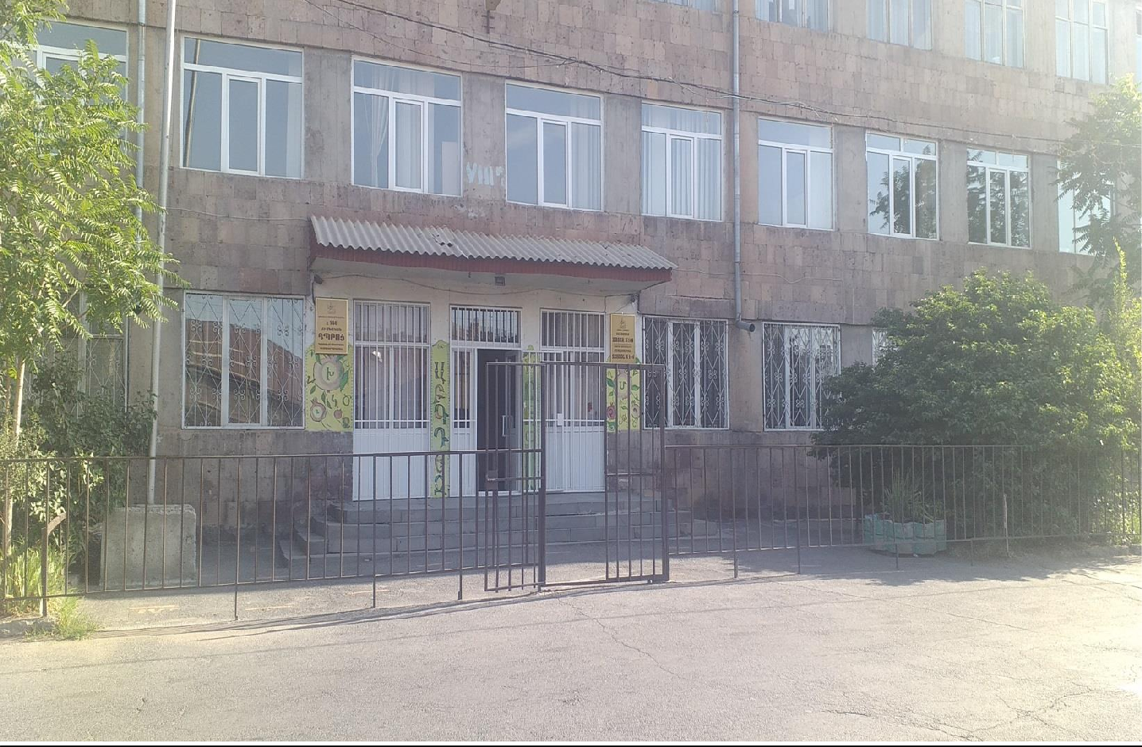





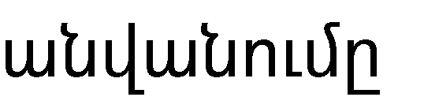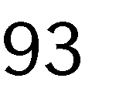

|  |  |  |  |
| --- | --- | --- | --- |
|  |  |  |  |
|  |  |  |  |
|  |  |  |  |
|  |  |  |  |
|  |  |  |  |
|  |  |  |  |
|  |  |  |  |
|  |  |  |  |
|  |  |  |  |
|  |  |  |  |
|  |  |  |  |
|  |  |  |  |
|  |  |  |  |



***′***

***′***



|  |  |  |  |  |
| --- | --- | --- | --- | --- |
|  |  |  | Սեպտեմբերի 1-ի դրությանբ |  |
|  |  | 28 |  |  |
|  |  | 25 | 25 |  |
|  |  |  |  |  |
|  |  | 41 |  |  |
|  |  | 43 | 41 |  |
|  |  | 49 | 46 |  |
|  |  | 19 | 41 |  |
|  |  | 22 |  |  |
|  |  | 23 | 22 |  |
|  |  | 282 | 271 |  |



|  |  |  |  |  |
| --- | --- | --- | --- | --- |
|  |  |  |  |  |
|  |  |  |  |  |
|  |  |  |  |  |
|  |  |  |  |  |
|  |  |  |  |  |
|  |  |  |  |  |



|  |  |  |  |
| --- | --- | --- | --- |
|  |  |  |  |
|  |  |  |  |
|  |  |  |  |
|  |  |  |  |
|  |  |  |  |
|  |  |  |  |



|  |  |  |  |  |
| --- | --- | --- | --- | --- |
|  |  |  |  |  |
|  |  |  |  |  |
|  |  |  |  |  |
|  |  |  |  |  |
|  |  |  |  |  |
|  |  |  |  |  |
|  |  |  |  |  |
|  |  |  |  |  |
|  |  |  |  |  |

















    
    
                                
    

