ԳԱՎԱՌԻ ԱՎԱԳ ԴՊՐՈՑ

Հերթական ատեստավորման ենթակաուսուցիչների վերապատրաստման դասընթաց
ՀԵՏԱԶՈՏԱԿԱՆ ԱՇԽԱՏԱՆՔ
ՀԵՏԱԶՈՏՈՒԹՅԱՆ ԹԵՄԱՆ՝
Պպոբլեմային ուսուցման արդյունավետությունը դասավանդման մեջ
Հետազոտող ուսուցիչ՝ Գավառի թիվ 3 հիմն. դպրոցի ուսուցիչ Սոֆյա Խաչիկյան
Ղեկավար՝ Նելլի Գափոյան

Գավառ 2022
ԲՈՎԱՆԴԱԿՈՒԹՅՈՒՆ

- Ներածություն------------------------------------------- 3
- Գրական ակնարկ-------------------------------------- 6
- Նպատակը և խնդիրները-------------------------- 8
- Հետազոտության ընթացք-------------------------- 8
- Ամփոփում------------------------------------------------ 18
- Գրականության ցանկ------------------------------ 19

Ներածություն
Պրոբլեմային ուսուցման տեխնոլոգիան մշակել է Ջոն Դյուին: Նա ասել է. «Մտածմունքը սկսվում է այնտեղ, որտեղ առկա է խնդրահարույց իրավիճակ»: Նրա առաջարկած այս բանաձևի հիման վրա էլ 20-րդ դարում դրվեց պրոբլեմային ուսուցման հիմքը:
Ժամանակակից կրթական հայեցակարգերում խրախուսելի են այնպիսի ուսուցման մեթոդներ և տեխնոլոգիաներ, որոնք առավել չափով են նպաստում սովորողների գիտելիքների հայտնաբերման գործընթացին: Այս տեսանկյունից պրոբլեմային ուսուցումը իր առաջատար տեղն ունի ուսուցման գործընթացում: Պրոբլեմային ուսուցում կոչվում է այն ուսուցումը, որի ընթացքում սովորողները իրենց ունեցած գիտելիքների հիման վրա լուծում են պրոբլեմային խնդիրներ, պրոբլեմային իրավիճակներ հաղթահարում, փնտրում գործողության նոր եղանակներ:
Պրոբլեմային ուսուցման բուն նպատակը աշակերտներին հսկայական ծավալով տեղեկատվությամբ ծանրաբեռնելը չէ, դրա նպատակն է օգնել աշակերտներին զարգացնել իրենց մտածողական, խնդիրների հանգուցալուծման և մտավոր հմտությունները, մտացածին և իրական իրավիճակների փորձով սովորել չափահասների խաղացած դերերը և դառնալ ավելի անկախ, ինքնուրույն սովորողներ, ցուցաբերել ստեղծագործական մոտեցում:
Այս մեթոդով ուսուցանելիս ոչ թե աշակերտը պետք է ստանա պատրաստի գիտելիքներ, այլ փնտրի և գտնի իր սեփական լուծումը, քանի որ նման գործողությունը ակտիվացնում է սովորողին, զարգացնում նրա մտածողությունը, ձևավորում հետաքրքրություն ուսուցանվող նյութի նկատմամբ, ուսուցանվող նյութը ավելի լավ է հիշվում, աշակերտի մոտ ձևավորվում է անծանոթ իրադրություններում կողմնորոշվելու, իր գիտելիքները կիրառելու ունակություն:
Այսպիսով, պրոբլեմային ուսուցման նպատակներն են.
- Աշակերտներին օգնել զարգացնել իրենց մտավոր և հետազոտական հմտությունները:
- Խորացնել չափահասների ունեցած դերերի ըմբռնումը:
- Օգնել աշակերտներին դառնալ ինքնուրույն:
(«Ժամանակակից մանկավարժական մոտեցումներ», Ձեռնարկ մանկավարժների և ուսանողների համար, էջ 205)
Ըստ Մ. Մախմուտովի` պրոբլեմային ուսուցման խնդիրներն են.
- Սովորել մտածել տրամաբանորեն, գիտականորեն և ստեղծագործաբար:
- Ուսումնական նյութը ավելի ցուցադրական և համոզիչ դարձնել սովորողների համար:
- Սովորողների մոտ ձևավորել ոչ միայն գիտելիք, այլ գիտելիք-համոզմունքներ, որոնք հիմք են հանդիսանում գիտական դիալեկտիկական աշխարհայացքի ձևավորման համար:
- Նպաստել ամուր գիտելիքներ ձեռք բերմանը, քանի որ ինքնուրույն ձեռք բերված գիտելիքները լավ են մտապահվում:
- Ներգործել սովորողների հուզական աշխարհի վրա՝ ձևավորելով ինքնավստահություն, ինտենսիվ մտավոր գործունեությունից բավարարվածություն:
- Ձևավորել որոնման և հետազոտական գործունեության տարրական հմտություններ:
- Ձևավորել և զարգացնել դրական վերաբերմունք ինչպես այս ուսումնական առարկայի, այնպես էլ ընդհանուր դասավանդման նկատմամբ:
(https://www.xn--d1abkefqip0a2f.xn--p1ai/index.php/region/item/826--55)
Կան պրոբլեմային իրավիճակների ստեղծման տարբեր եղանակներ.
- Անալոգիայի եղանակ
Այս դեպքում ուսուցիչը հենվում է սովորողների փորձի վրա կամ արդիականացնում է նրանց նախկինում ստացած գիտելիքները՝ նոր խնդիրների լուծման մեջ:
- Մակածական – վերլուծական – համադրական եղանակ
Այս դեպքում սովորողներն ինքնուրույն են ասում երևույթն ու փաստերը և անհրաժեշտ եզրահանգումներ անում:
- Ուսումնասիրվող այս կամ այն երևույթի պատճառների որոնում
Այս եղանակը կիրառվում է այն դեպքում, երբ խնդրի լուծման կամ նոր գիտելիքի ձեռք բերման համար անհրաժեշտ է գործածել ավելի վաղ ուսումնասիրված սկզբունք կամ օրինաչափություն:
- Հակասական փաստի հաղորդում
Պրոբլեմային ուսուցման տեխնոլոգիան ենթադրում է նաև սովորողներին հակասական իրողությունների, փաստերի հաղորդում: Սովորողները պետք է կարողանան հիմնավորել այդ հակասությունը օրինակների միջոցով:
- Պրոբլեմային իրավիճակների ստեղծում
Սովորողներին առաջարկել պրոբլեմային իրավիճակներ, տեսնել, թե նրանք ինչպես են հաղթահարում (Սիմոնյան Մ., 2021թ., էջ 3.4)
Պրոբլեմային ուսուցումը իր մեջ ներառում է հետևյալ փուլերը՝
1 – րդ փուլ. Պրոբլեմի առանձնացում և պրոբլեմի ձևակերպում
2 - րդ փուլ. Պրոբլեմի նկատմամբ հետաքրքրության առաջացում
3 – րդ փուլ. Պրոբլեմային հարցի ձևակերպում
4 – րդ փուլ. Պրոբլեմային իրավիճակի ստեղծում
5 – րդ փուլ. Սովորողների ինքնուրույն աշխատանք
6 – րդ փուլ. Պրոբլեմի որոնում և հետազոտական աշխատանք
7 – րդ փուլ. Պրոբլեմի լուծում
Խնդրակենտրոն կամ պրոբլեմային դասավանդման մոդելով առաջնորդվող ուսուցիչները գործուն մասնակցություն են ունենում աշակերտների՝ հետազոտության խնդիր ընտրելու հարցում, քանի որ դա աշակերտներին ավելի է ոգևորում:
Օրինակելի պրոբլեմային իրավիճակը առնվազն պետք է բավարարի հետևյալ 5 չափանիշներին.
- Պետք է իրական լինի, այսինքն՝ խնդիրը պետք է խարսխված լինի ոչ թե գիտության, տվյալ ճյուղի սկզբունքների, այլ աշակերտի իրական կենսափորձի վրա:
- Խնդիրը պետք է որոշ չափով ոչ հստակ ձևակերպում ունենա, որպեսզի իր խորհրդավորությամբ ու խճճվածությամբ գրավի աշակերտին:
- Խնդիրը պետք է իմաստալից լինի և համապատասխանի աշակերտների մտավոր զարգացման մակարդակին:
- Խնդիրը պետք է բավարար չափով ընդգրկուն լինի, որպեսզի ուսուցիչը հնարավորություն ունենա իրագործել իր ուսուցողական նպատակը:
- Ցանկալի է, որ օրինակելի խնդրի լուծումը խմբային աշխատանք ներառի:
Ուսուցման պրոբլեմային մեթոդը լայն հնարավորություններ է ստեղծում գեղագիտական արժեքների ձևավորման համար: Այդ ընթացքում դրսևորվում են մաթեմատիկական գեղեցիկի այնպիսի հատկանիշներ, ինչպիսիք են կարգը, հստակությունը, պարզությունը, անսպասելիությունը, համընդհանրությունը: Այդ արժեքները իրենց հերթին մեծացնում են մաթեմատիկական նյութի նկատմամբ հետաքրքրությունը, սովորողին մղում ստեղծագործական ակտիվություն:
Նշեմ, որ պրոբլեմային ուսուցումը ունի նաև թերություններ: Այդ մեթոդով ուսուցման համար պահանջվում է երկար ժամանակ, պրոբլեմային իրավիճակներ ստեղծելու, համապատասխան խնդիրներ կազմելու համար ուսուցիչը պետք է դրսևորի մեծ վարպետություն, պրոբլեմի լուծման համար առաջադրվող քայլերի հերթականությունը սովորողին զրկում է լուծման ինքնուրույն ճանապարհ գտնելու հնարավորությունից և այլն: Նշեմ նաև, որ պրոբլեմային ուսուցումը, ինչպես նաև ցանկացած այլ մեթոդ կիրառելիս նպատակահարմար է այն կիրառել ոչ թե ամբողջ դասի ընթացքում, այլ դրա առանձին հատվածների ուսուցումը կազմակերպելիս:

Գրական ակնարկ

Յուրաքանչյուր աշակերտ, որն առաջին քայլերն է անում մաթեմատիկայում, վստահ չէ իր ուժերի վրա: Նրան թվում է, թե չի կարող ինքնուրույն մտածել, գտնել պրոբլեմի լուծման քայլաշարը: Ամենադժվարը հենց սա է` կոտրել այն պատնեշը, որը սովորողին թույլ չի տալիս առաջ գնալ, հավատալ իր ուժերին, զգալ ընկերների աջակցությունը, ապրել երկար փնտրած լուծումը գտնելու բերկրանքը: Այս ամենին հասնելու համար պետք է ընտրել նշանակետին խփող ճիշտ ռազմավարություն, այն է` համապատասխան մեթոդներ, մոտեցումներ, որոնք աշակերտին կօգնեն սովորել մտածել, զարգացնել տրամաբանությունը: Որպես այդպիսի մեթոդ կարելի է նշել պրոբլեմային ուսուցումը:
Սույն հետազոտական աշխատանքի նպատակն է ցույց տալ պրոբլեմային ուսուցման մեթոդի կիրառության առավելությունը` դասապրոցեսներում աշակերտների ակտիվության, հետաքրքրասիրության և վերլուծական, քննադատական մտածողության զարգացման գործում:
Պրոբլեմային իրավիճակներ ստեղծելու համար ուսուցիչը պետք է տիրապետի հետևյալ մեթոդական հնարքներին․
- Նախնական տնային հանձնարարություններ։ Դրանք հնարավորություն են տալիս սովորողին դասի ընթացքում ներկայացնել այն ուսումնական պրոբլեմներն ու իմացական դժվարությունները, որոնց առնչվել է։
- Նախնական տնային հանձնարարությունների ներկայացումը դասարանին։ Այդ հանձնարարությունները նպատակահարմար է ներկայացնել նոր նյութի ուսուցումից առաջ՝ սովորողների իմացական հետաքրքրությունները մեծացնելու, ուշադրությունը ակտիվացնելու, ընկալումը առավել նպատակասլաց դարձնելու համար։
- Սովորողների կողմից կատարած առօրյա դիտարկումներից և փորձերից ստացած արդյունքների օգտագործում։ Իրենց գործողություններում թույլ տված անճշտությունները սովորողի մոտ առաջացնում են նոր գիտելիքի պահանջ։
- Փորձարարական և տեսական իմացական խնդիրների լուծում։ Այդպիսի խնդիրների լուծումը սովորողին հնարավորություն է տալիս ստանալ նոր գիտելիքներ և իմացության նոր հնարքներ։
- Հետազոտության տարրեր պարունակող խնդիրներ, որոնք նպաստոմ են սովորողների որոշակի կարողությունների ու հմտությունների ձեռք բերմանը, առաջացնում են պրոբլեմային իրավիճակներ, ծանոթացնում են գիտական հետազոտության մեթոդներին։
- Իրավիճակ, որը ներառում է առաջին հայացքից հեշտ թվացող գործնական բնույթի գործողություններ պարունակող առաջադրանքներ։
- Ընտրություն կատարելու իրավիճակի ստեղծում։ Նման իրավիճակ առաջանում է, երբ սովորողը պետք է կողմնորոշվի հարցը տարբեր տեսանկյունից դիտարկելու, ավելորդ կամ պակաս տվյալով խնդիրը լուծելու, կամ խնդրի մի քանի եղանակով լուծումներից ռացիոնալը ընտրելու ընթացքում։
- Պրոբլեմային հարցերի ներկայացում և բանավեճերի կազմակերպում։ Հայտնի է, որ տարբեր տեսակետերի առաջադրումը ուժեղացնում է իրավիճակի պրոբլեմայնությունը և ակտիվացնում է որոնումը։
- Միջառարկայական կապերի օգտագործում։ Հարակից առարկաների գիտելիքների կիրառումն ակտիվացնում է ուսումնառությունը, մեծացնում է սովորողների հետաքրքրությունը, մղում է նրանց ստեղծագործական գործունեության։
Մանկավարժության մեջ կիրառվում է պրոբլեմային ուսուցման չորս մակարդակ.
Ա. Ուսումնական նյութի պրոբլեմային շարադրանքի մակարդակ
Այս մակարդակում ուսուցիչը սովորողներին ներկայացնում է ուսումնական տեղեկատվություն, ձևակերպում է պրոբլեմը, ցուցադրում է լուծման հնարավոր ուղիները։
Բ․ Պրոբլեմային իրավիճակները անալոգիայով լուծելու մակարդակ
Այս մակարդակում ուսուցիչը ձևակերպում է պրոբլեմը, բացատրում դրա իմաստը և առաջարկում է սովորողներին պրոբլեմը լուծել ինքնուրույն։
Գ․ Մինի-հետազոտական մակարդակ
Այս մակարդակում ուսուցիչը ձևակերպում է պրոբլեմը, որոշում է այն ուսումնական գիտելիքները, որոնք անհրաժեշտ են պրոբլեմի լուծման համար։ Սովորողները ինքնուրույն լուծում են պրոբլեմը՝ գտնում պատասխանը և առաջարկում լուծման այլ տարբերակներ։
Դ․ Հետազոտական մակարդակ
Սովորողներին առաջարկվում է լուծել պրոբլեմային իրավիճակ, որը նրանց անծանոթ է։ Սովորողները, ելնելով դասի խնդիրներից, իրենք են առաջադրում իրենց անծանոթ պրոբլեմային իրավիճակ, այնուհետև, հենվելով նախկինում ստացած գիտելիքների վրա, ինքնուրույն լուծում են պրոբլեմը։
Պրոբլեմային իրավիճակները հաղթահարելուց հետո սովորողները ամփոփում և հաշվետվություն են ներկայացնում հետազոտության արդյունքների մասին։

Նպատակներն ու խնդիրները

Հաշվի առնելով պրոբլեմային ուսուցման առանձնահատկությունները՝ հետազոտական աշխատանքի նպատակն էր ուսումնասիրել պրոբլեմային ուսուցման արդյունավետությունը մաթեմատիկա առարկայի դասավանդման գործընթացում: Աշխատանքի նպատակից բխում են հետևյալ խնդիրները.
● Դասարանի ուսումնասիրում և աշակերտների մոտ առկա խնդիրների բացահայտում
● Անհրաժեշտ գրականության ուսումնասիրում և համապատասխան ռազմավարության ընտրություն:
● Աշակերտների համար համապատասխան առաջադրանքների կազմում:
● Անհրաժեշտ վկայությունների հավաքագրում:

Հետազոտության ընթացքը
Հետազոտության համար ընտրել եմ 6-րդ դասարանը: Նույն դասարանում երկու դասապրոցեսներ (առաջինում չեմ կիրառել պրոբլեմային ուսուցումը, երկրորդում` կիրառել եմ) անցկացնելու միջոցով արձանագրել եմ պրոբլեմային ուսուցման մեթոդի առավելությունը:
6–րդ դասարանում կա 12 աշակերտն` 8 աղջիկ և 4 տղա: Աշակերտներից երկուսը լավ են սովորում, աշխատասեր են, քիչ են բացակայում և հետաքրքրված են մաթեմատիկայով: Առարկայից միջին մակարդակի գիտելիքներ ունի 7 աշակերտ: Նրանք դժվար են ներգրավվում դասապրոցեսում, անընդհատ շեղվում են և ուսուցչի ուշադրությունից դուրս մնալու դեպքում կարող են այլ բանով զբաղվել: Աշակերտներից երեքն էլ ընդհանրապես չեն լսում ու հետաքրքրություն չեն ցուցաբերում մաթեմատիկայի նկատմամբ: Առաջին դասապրոցեսը անցկացրել եմ «Տեքստային խնդիրների լուծումը» թեմայով` ավանդական մեթոդներով` հարց ու պատասխան, բանավոր հարցում, համառոտ դասախոսություն, խնդիրների լուծում:
Աշակերտների քիչ մասը մասնակցեցին դասապրոցեսին, չկար ոգևորություն և համագործակցություն: Հաշվի առնելով, որ դասարանի աշակերտների մեծ մասն ունի մաթեմատիկական գիտելիքների միջին մակարդակ` ընտրել էի միջին բարդության չորս խնդիր, որոնք չեն պահանջում ոչ ստանդարտ լուծումներ, բայց այնուամենայնիվ ոչ մի աշակերտ չկարողացավ լուծել բոլոր խնդիրները, աշակերտների մեծ մասին հետաքրքիր չէր խնդիր լուծելու գործընթացը: Աշակերտներից 8–ը ընդհանրապես չէր հետևում դասապրոցեսին: Բայց ահա նույն թեման այդ դասարանում ուսուցանել եմ պրոբլեմային ուսուցման մեթոդով, և լավ արդյունքն ակնհայտ էր: Խնդրի լուծմամբ հետաքրքրված էր դասարանի 12 աշակերտներից 8-ը, մինչդեռ առաջին դասապրոցեսում այդպիսի աշակերտների թիվը 4-ն էր: Ակնհայտ է սովորողների հետաքրքրասիրությունն ու ոգևորությունը, ինչպես նաև ավելի շատ խնդիրներ լուծելու ցանկությունը: .Ստորև ներկայացվում են այդ երկու դասապրոցեսների ընթացքը:
Առաջին դասապրոցես
Դասի թեման՝ «Տեքստային խնդիրների լուծումը»
Դասարանը՝ 6-րդ
Տիպը՝ ընդհանրացման համակարգման դաս
Մեթոդները՝ բանավոր հարցում, համառոտ դասախոսություն, խնդիրների լուծում Թեմայի արդիականացում՝ արվում է առօրյայում հանդիպող կիրառական խնդիրներում:
Օգտագործվող նյութեր՝ Գ. Նահապետյան, Ա. Աբրահամյան, «Մաթեմատիկա 6», Մանմար, 2016
Ամբողջական պատկեր, դասի նպատակ.
Սովորողները գիտեն՝ ինչ է տեքստային խնդիրը, ծանոթ են դրա լուծման թվաբանական և հանրահաշվական եղանակներին: Այս դասին աշակերտները ներկայացրեցին Անանիա Շիրակացու կյանքի կարևոր դրվագները և լուծեցին մի քանի խնդիր: Դասի թեման կապված է կյանքի հետ, քանի որ յուրաքանչյուր քայլափոխին առնչվում ենք որևէ խնդրի հետ:
Վերջնարդյունքները.
Աշակերտը կկարողանա տարբերել խնդրի պայմանը, հարցը, լուծումը և պատասխանը: Կկարողանա կիրառական պարզագույն խնդիրների համար կազմել հավասարումներ, հավասարումների համակարգեր և լուծել դրանք:
Դասի ընթացքը. խթանման փուլ (5ր.).
Դասի սկզբում համառոտ դասախոսության մեթոդով կարևորեցի մաթեմատիկայի կիրառական ուղղվածությունը, այսինքն՝ տարբեր իրավիճակներում մաթեմատիկայի միջոցով ճիշտ կողմնորոշվելն ու ցանկացած խնդրի ռացիոնալլ լուծում գտնելը: Ի վերջո, մաթեմատիկայի մեծ կոչումը հենց դրա մեջ է` քաոսի մեջ կարգ գտնել:
Իմաստավորման փուլ (10ր.)
Քանի որ մեծ գիտնական և մաթեմատիկոս Անանիա Շիրակացին հանդիսանում է Հայաստանում բնական գիտությունների հիմնադիրը և ունի տեքստային խնդիրների ժողովածու, ես հարկ համարեցի, որ աշակերտները ներկայացնեն իրենց նախօրոք պատրաստած նյութը` Շիրակացու կյանքի և գործունեության կարևոր դրվագները և լուծեցինք մի քանի խնդիրներ Ա. Շիրակացու գրքից:
Կշռադատման փուլ (20ր)
Հանձնարարում եմ աշակերտներին ինքնուրույն լուծել հետևյալ խնդիրները (բոլոր խնդիրների լուծումները գրվեցին գրատախտակին և բացատրվեցին նախ աշակերտի կողմից, ապա՝ իմ:
- Գնացքը A քաղաքից B քաղաքն էր գնում 55կմ/ժ արագությանբ, իսկ B-ից A՝ 60կմ/ժ արագությամբ: A -ից B գնալու և վերադառնալու համար, չհաշված կանգառները, գնացքին անհրաժեշտ եղավ 23ժ: Քանի կիլոմետր էր A-ից մինչև B:
- Բանվորների մի խումբ կատարել է ամբողջ աշխատանքի 25 տոկոսը, երկրորդը՝ մնացածի 40 տոկոսը: Աշխատանքն ավարտել է երրորդ խումբը: Ամբողջ աշխատանքի որ տոկոսն է կատարել երրորդ խումբը:
- Երևանից Գյումրի 120 կմ-անոց ճանապարհը ավտոմեքենան անցավ 40 կմ/ժ արագությամբ և վերադարձավ 60 կմ/ժ արագությամբ: Որքա՞ն կլինի ավտոմեքենայի միջին արագությունը:
- Նավակի արագությունը գետի հոսանքի ուղղությամբ 15կմ/ժ է, իակ հոսանքին հակառակ՝ 19կմ/ժ: Որքա՞ն է գետի հոսանքի արագությունը:
Ամփոփում (5ր.)
Աշակերտներին բաժանեցի հարցաթերթիկներ, որոնք նրանք լրացնում են ինքնուրույն (հարցման արդյունքները նշված են հավելվածում`առաջին դասապլանի վերջում):
Գնահատում և տնային աշխատանքի հանձնարարում ( 5 ր )
ԵՐԿՐՈՐԴ ԴԱՍԱՊՐՈՑԵՍ
Դասի թեման՝ «Տեքստային խնդիրների լուծումը»
Դասարանը՝ 6-րդ
Օգտագործվող նյութեր՝ Գ. Նահապետյան, Ա. Աբրահամյան, «Մաթեմատիկա 6», Մանմար, 2016
Ամբողջական պատկեր, դասի նպատակ
Սովորողները գիտեն՝ ինչ է տեքստային խնդիրը, ծանոթ են դրա լուծման թվաբանական և հանրահաշվական եղանակներին: Այս դասի նպատակն է մանրամասն ներկայացնել խնդրի լուծման փուլերը, վերլուծել դրանք պրոբլեմային ոսուցման մեթոդի կիրառությամբ լուծվող մի խնդրի օրինակով: Բացահայտել դասապրոցեսներում պրոբլեմային ուսուցման մեթոդի կիրառման առավելությունը, ինչպես նաև զարգացնել աշակերտների համագործակցային, պատասխանատվության և առաջնորդության կարողունակությունները:
Վերջնարդյունքները
- Աշակերտը կկարողանա կիրառական պարզագույն խնդիրների համար կազմել հավասարումներ և լուծել դրանք:
- Կկարողանա կիրառական տարբեր խնդիրներ մոդելավորել, կազմել հավասարումներ և լուծել դրանք:
Դասի տիպը՝ ընդհանրացման - համակարգման դաս:
Մեթոդները՝ բանավոր հարցում, համառոտ դասախոսություն, էվրիստիկ զրույց, պրոբլեմային ուսուցում, խմբային աշխատանք:
Թեմայի արդիականացում՝ արվում է առօրյայում հանդիպող կիրառական խնդիրներում:
Ընթացքը՝ խթանման փուլ (5ր.)
Համառոտ դասախոսության մեթոդով ներկայացնում եմ աշակերտներին հետևյալը. Առօրյայում անընդհատ առնչվում ենք տարբեր պրոբլեմների, իրավիճակների, որոնցից դուրս գալը մեզ կանգնեցնում է այս կամ այն պրոբլեմի առջև, որը հանգեցնում է համապատասխան տեքստային խնդրի լուծմանը, ուստի շատ կարևոր է, որ սովորողն իմանա դրա լուծման, այսպես ասած, «այբուբենը»:
Իմաստավորման փուլ (10 ր.)
Ներկայացնում եմ խնդիրների լուծման մեթոդները.
- թվաբանական մեթոդ (խնդրի լուծումը գտնում են թվերի հետ թվաբանական գործողություններ գործողություններ կատարելով ),
- հանրահաշվական մեթոդ (անհայտի կամ անհայտների ներմուծմամբ կազմվում է խնդրի հանրահաշվական բանաձևը),
- տրամաբանական մեթոդ (այս դեպքում տրամաբանելով են գտնում խնդրի լուծումը),
- պատկերային մեթոդ (հատվածների, շրջանների և այլ երկրաչափական պատկերների միջոցով) և այլն:
Այնուհետև նշում եմ հետևյալը.
Խնդիրը հասկանալը, համառոտագրելը և հավասարում կազմելը դրա լուծման առանցքային փուլն է, որտեղ խնդրում նկարագրված կենցաղային պայմանները թարգմանվում են մաթեմատիկական լեզվով: Սա լուրջ ստեղծագործական աշխատանք է: Հաջորդ փուլում լուծվում է այդ հավասարումը, որն արդեն զուտ մաթեմատիկական - մեխանիկական աշխատանք է: Վերջին փուլում նորից անդրադառնում ենք խնդրի պահանջին, որպեսզի ճիշտ նշենք պատասխանը: Սա ևս շատ կարևոր է, որովհետև աշակերտը պետք է սովորի ճիշտ նշել խնդրի պատասխանը, քանի որ քննություների ժամանակ ստուգվում է միայն ձևաթղթի նմուշը:
Ստացվում է, որ խնդիրը հասկանալու, մոդելավորելու և հավասարում կազմելու համար պետք է անհամեմատ ավելի շատ ժամանակ ծախսել, քան բուն հավասարումը լուծելու համար:
Կշռադատման փուլ (20 ր.)
Այս բացատրություններից հետո դասարանը բաժանում եմ երկու խմբերի, որոնց հանձնարարում եմ լուծել հետևյալ խնդիրը.
Խնդիր. Մի բանվորը, աշխատելով մենակ, կարող է ավարտել տրված աշխատանքը 18 օրում, իսկ մյուսը՝ 36 օրում: Միասին աշխատելով՝ քանի՞ օրում կարող են այդ աշխատանքը կատարել (4, էջ 68):
Խմբերը սկսում են աշխատել և համագործակցության արդյունքում, լուծում են այն ստանդարտ եղանակով.
Առաջին բանվորը 1 օրում կկատարի աշխատանքի 1/18 մասը:
Երկրորդ բանվորը 1 օրում կկատարի աշխատանքի 1/36 մասը:
Միասին 1 օրում կկատարեն 1/18+1/36=1/12 մասը:
Ամբողջ աշխատանքը միասին կկատարեն 1:1/12 = 12 օր: Պատասխան`12
Խմբերի անդամները ուրախ էին և ոգևորված` խնդրի պատասխանը ստանալուց հետո: Նրանք, այդ թվում նաև թույլ սովորող աշակերտները չէին պատկերացնում, որ կկարողանան ինքնուրույն մտածել, վերլուծել և խնդրի լուծման քայլեր մշակել:
Այնուհետև դիմում եմ խմբերին.
- Հիմա ուշադրություն, հարցը փոխվում է` դուք պետք է մտածեք և խնդիրը լուծեք այլ եղանակով, որպեսզի լուծումը հասկանալի լինի նույնիսկ 5–րդ դասարանի աշակերտին (հետաքրքրության առաջացման և պրոբլեմային հարցի ձևակերպման փուլեր): Ձեզ տրվում է 10 ր. ժամանակ` ավելի պարզ լուծում գտնելու համար (պրոբլեմային իրավիճակի ստեղծման փուլ):
Խմբերի բոլոր անդամները մեծ հետաքրքրությամբ ներգրավվում են խնդրի լուծման մեջ, առաջարկություններ և լուծումներ են առաջ քաշվում (պրոբլեմի որոնման և հետազոտական աշխատանքի փուլ):
Մի խմբին հաջողվում է լուծել այն.
Գտնենք 18 –ի և 36-ի ամենափոքր ընդհանուր բազմապատիկը` 36-ը:
Առաջին բանվորը 36 օրում կկատարի այդ աշխատանքի կրկնակին՝ 2 մաս:
Երկրորդ բանվորը 36 օրում կկատարի 1 մաս:
Միասին` 36 օրում կկատարեն 3 մաս աշխատանք, ուստի միասին 1 մաս աշխատանքը կկատարեն 36:3 = 12 օրում
Պատասխան`12 (պրոբլեմի լուծման փուլ):
Խմբերի անդամները շատ ոգևորված էին, բոլորի աչքերը փայլում էին:
Ամփոփում (5 ր.)
Աշակերտները լրացնում են հարցաթերթիկները (հարցման արդյունքները նշված են վերջում):
Գնահատում և տնային աշխատանքի հանձնարարում (5ր.)
Այս դասից հետո աշակերտները մոտեցան ինձ և հայտնեցին իրենց հրճվանքն ու գոհունակությունը դասի վերաբերյալ և խնդրեցին մյուս անգամ նույնպես նման ձևով լուծել ուրիշ խնդիրներ: Նույնիսկ թույլ աշակերտներից մեկը խնդրեց տալ իրեն երկու հեշտ խնդիր` որպես տնային առաջադրանք:
Ստորև ներկայացնում եմ երկու դասապրոցեսների վերջում աշակերտների լրացրած հարցաթերթիկները`
ԱՌԱՋԻՆ ԴԱՍԱՊՐՈՑԵՍԻ ԱՐԴՅՈՒՆՔՆԵՐԸ
Աշակերտ | Քանի՞ խնդիր լուծեցիր ինքնուրույն | Հետաքրքի՞ր էր: | Կցանկանայի՞ր էլի խնդիր լուծել:
ԱԱ | 1 | ոչ | ոչ
ԱՆ | 0 | ոչ | ոչ
ԳԿ | 0 | ոչ | ոչ
ԳԴ | 2 | այո | այո
ԵԲ | 1 | ոչ | ոչ
ԶԼ | 0 | ոչ | ոչ
ԶՆ | 3 | այո | այո
ԹՀ | 0 | ոչ | ոչ
ԹՄ | 1 | ոչ | ոչ
ԽՄ | 0 | ոչ | ոչ
ԽՅ | 2 | այո | այո
ՀՄ | 0 | այո | ոչ

ԵՐԿՐՈՐԴ ԴԱՍԱՊՐՈՑԵՍԻ ԱՐԴՅՈՒՆՔՆԵՐԸ

Աշակերտ | Քանի՞ խնդիր լուծեցիր ինքնուրույն | Հետաքրքի՞ր էր | Կցանկանայի՞ր էլի խնդիր լուծել
ԱԱ | 1 | այո | այո
ԱՆ | 0 | ոչ | ոչ
Գկ | 2 | այո | այո
ԳԴ | 1 | այո | այո
ԵԲ | 2 | այո | այո
ԶԼ | 0 | ոչ | ոչ
ԶՆ | 3 | այո | այո
ԹՀ | 0 | ոչ | ոչ
ԹՄ | 1 | այո | այո
ԽՄ | 0 | ոչ | ոչ
ԽՅ | 2 | այո | այո
ՀՄ | 1 | այո | այո

Այսպիսով, պրոբլեմային ուսուցման կիրառության պարագայում երկրորդ դասապրոցեսի ընթացքում աննախադեպ աճ գրանցվեց: Ներկայացնենք երկու դասապրոցեսների վերջնական արդյունքների համեմատական բնութագիրը` հետևյալ սյունակային դիագրամի միջոցով.

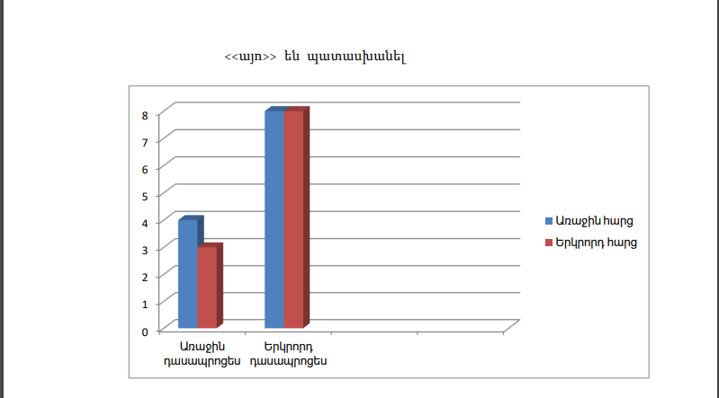

Բերեմ մի քանի խնդիրների օրինակներ, որոնց լուծման համար կարելի է պրեբլեմային իրավիճակ ստեղծել դասարանում:
Օրինակ. 8-րդ դասարանում եռանկյան կիսորդի հատկությունը անցնելիս կարելի է ոչ միանգամից տալ դրա ձևակերպումն ու ապացույցը, այլ կարելի գծել MNK հավասարասրուն եռանկյուն և աշակերտներին հարցնել դրա մեջ հիմքին տարած կիսորդի մասին թեորեմը: Այնուհետև առաջարկել հաշվել MH:HK, MN:NK հարաբերությունները: Աշակերտները կհաշվեն և կտեսնեն, որ հավասար են: Աշակերտներին առաջարկել նման հետևություն անել նաև ցանկացած եռանկյան համար: Դրանում համոզվելու համար հանձնարարել, որ զույգերով աշխատեն՝ համապատասխան չափումներ անեն և կատարեն հետևություն, որ ցանկացած եռանկյան անկյան կիսորդը հանդիպակաց կողմը տրոհում է 2 հատվածների, որոնք համեմատական են կից կողմերին: Նշված թեորեմի ապացուցումը աշակերտներին առաջարկել տանը ինքնուրույն սովորել գրքից, իսկ դասարանում նրանց ուշադրությունը գրավել հետևյալ ապացուցման եղանակի վրա.
ENH և FNH եռանկյուններն ունեն 2-ական հավասար բարձրություններ, նրանց մակերեսների հարաբերությունը մի կողմից հավասար է EN:NF հարաբերությանը, իսկ մյուս կողմից՝ EH:HF հարաբերությանը: Իսկ դա նշանակում է, որ EN:NF=EH:HF: Վարկածը հիմնավորված է:

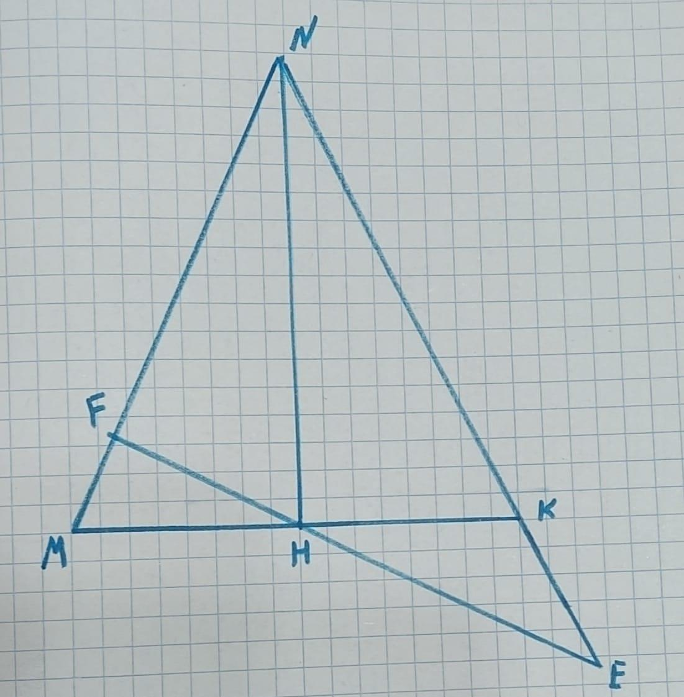

Կարելի է 9-րդ դասարանի աշակերտներին հանձնարարել գտնել հետևյալ հակասության պատճառը, երբ նրանք անցնում են «Մակերեսներ» թեման երկրաչափություն առարկայից:
Խնդիր. 8սմ կողմ ունեցող քառակուսին տրոհել չորս մասի և այդ մասերով կազմել` 5սմ և 13սմ կողմերով ուղանկյուն: Մակերեսի հատկության համաձայն՝ նշված մասերից կազմված պատկերները պետք է ունենան նույն մակերեսը: Բայց քառակուսու մակերեսը 64 քառ.սմ է, իսկ ուղղանկյան մակերեսը՝ 65 քառ սմ: Ի՞նչն է այդ հակասության պատճառը:
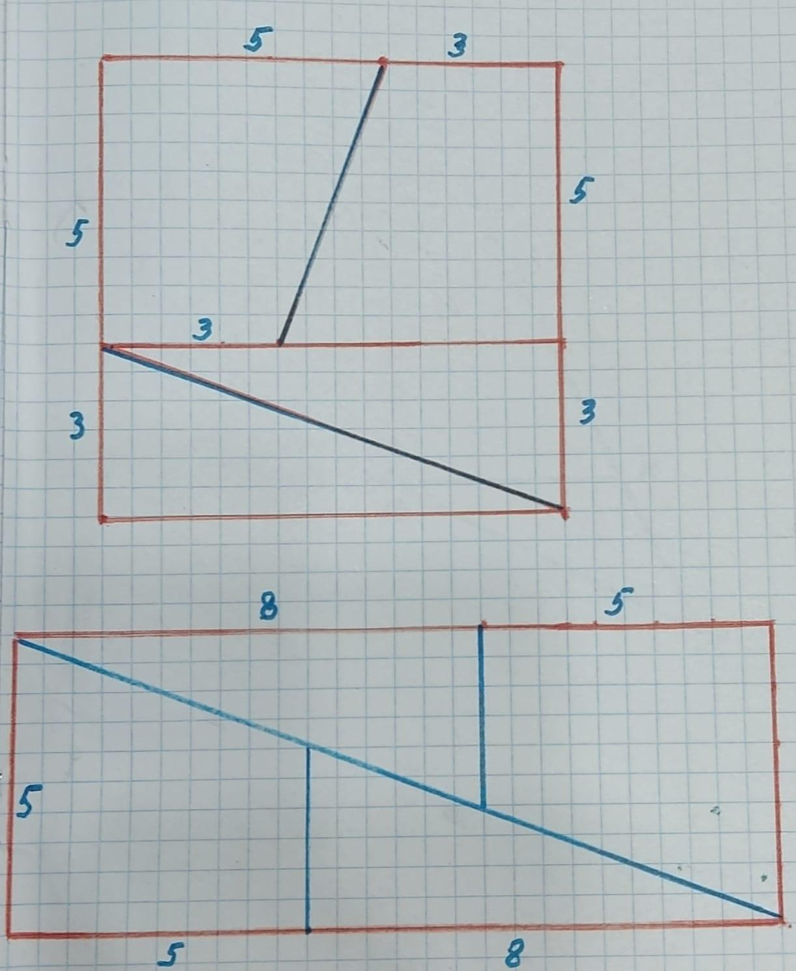

9- րդ դասարանում, երբ աշակերտները անցնում են «Հաջորդականություններ» թեման, կարելի է առաջարկել հետևյալ խմբային առաջադրանքը:
Առաջադրանք Ա. Կազմել Ֆիբոնաչիի հաջորդականության 10 հաջորդական անդամներ և գտնել դրանց գումարը: Մինչ սովորողները կավարտեն հաշվումները, ուսուցիչը յուրաքանչյուր խմբի կազմած հաջորդականության 7-րդ անդամը մտքում բազմապատկում է 11-07-11-ով և արդյունքները գրում գրատախտակին: Երբ սովորողները նկատում են, որ դրանք իրենց առաջադրանքի պատասխաններն են, նրանց հետաքրքրությունը մեծանում է, առաջանում է զարմանքի ու տարակուսանքի մթնոլորտ: Ուսուցիչը բացահայտում է պրոբլեմի մաթեմատիկական գաղտնիքը,այսինքն`այն հատկությունը, որից օգտվել է: Այնուհետև սովորողներն անցնում են տվյալ հատկության հիմնավորումը լուսաբանող հետևյալ առաջադրանքի կատարմանը:
Առաջադրանք Բ. Ապացուցել, որ Ֆիբոնաչիի հաջորդականության հաջորդական 10 անդամների գումարը հավասար է 7-րդ անդամի և 11 թվի արտադրյալին:

Ամփոփում
Այսպիսով, պրոբլեմային ուսուցումը դասապրոցեսում կարող է ապահովել աշակերտների ակտիվությունը, խթանել նրանց հետաքրքրասիրությունը, քանի որ հնարավորություն է տալիս ստեղծագործել, մտածել և ապրել փնտրածը գտնելու բերկրանքը: Հետազոտության ընթացքում պարզվեց, որ այս ուսուցումը կիրառելիս բարձրանում է աշակերտների մոտիվացիան, հետաքրքրությունների շրջանակը ընդլայնվում է, նրանց մղում է ինքնուրույն մտածել, գտնել լուծումներ, համագործակցել, մեկը մյուսին սովորեցնել, լինել ինքնավստահ, աշակերտները ձեռք են բերում իրենց հետագա կյանքում առաջադրանքներն ինքնուրույն կատարելու ձիրք և ինքնուրույնություն:
Հետազոտություն կատարելիս ես ստացա նաև այնպիսի գիտելիքներ մաթեմատիկա առարկայից, որոնց մասին չգիտեի, օրինակ՝ Ֆիբոնաչիի հաջորդականության հետաքրքրիր հատկության մասին, անկյան կիսորդի ապացուցման նոր եղանակ սովորեցի, Պյութագորասի թեորեմի մի քանի ապացուցման եղանակների ծանոթացա:

Օգտագործված գրականության ցանկ
- Կառուցողական կրթության հիմունքները և մեթոդները
- Միքայելյան Հ, (2013) «Մաթեմատիկայի ուսուցման մեթոդների գեղագիտական գրավչությունը», Մաթեմատիկան դպրոցում, 5 (92)
- Ժամանակակից մանկավարժական մոտեցումներ - Ձեռնարկ մանկավարժների և ուսանողների համար (էջ 197 - 207)
- Բ. Նահապետյան, Ա. Աբրահամյան, 6 -րդ դասարանի մաթեմատիկա
- https://www.xn--d1abkefqip0a2f.xn--p1ai/index.php/region/item/826--55

