ՎԵՐԱՊԱՏՐԱՍՏՎՈՂ ՈՒՍՈՒՑՉԻ
ՀԵՏԱԶՈՏԱԿԱՆ ԱՇԽԱՏԱՆՔ

ԱՌԱՐԿԱ՝ ՄԱԹԵՄԱՏԻԿԱ
Հետազոտության թեման՝
ՄԱԹԵՄԱՏԻԿԱՆ ԱՌՕՐՅԱ ԿՅԱՆՔՈՒՄ

ՈՒՍՈՒՑԻՉ՝ ՔՆՔՈՒՇ ԱՎԱԳՅԱՆ
ԴՊՐՈՑ՝ ԳԱՎԱՌԻ ԳԵՈՐԳԻ ՄՆԱՑԱԿԱՆՅԱՆԻ ԱՆՎԱՆ ԹԻՎ
7 ՄԻՋՆԱԿԱՐԳ ԴՊՐՈՑ
ՂԵԿԱՎԱՐ՝ ՆԵԼԼԻ ԳԱՓՈՅԱՆ

ԳԱՎԱՌ – 2022

Բովանդակություն

Ներածություն------------------------------------------------------------------------- 3
Գրական ակնարկ-------------------------------------------------------------------- 4
ՄԱԹԵՄԱՏԻԿԱՆ ՈՐՊԵՍ ԱՌԱՐԿԱ և ՈՐՊԵՍ ԿԵՆՍԱԿԱՆ
ԲԱՂԱԴՐԻՉ------------------------------------------------------------------------------5
ԹԵՈՐԵՄՆԵՐ ---------------------------------------------------------------------------6
ՀԱՄԱՉԱՓՈՒԹՅՈՒՆԸ ԿԱՄ ՍԻՄԵՏՐԻԱՆ -----------------------------------8
ՄԻՋԱՌԱՐԿԱՅԱԿԱՆ ԿԱՊԵՐ----------------------------------------------------14
Անդրադարձ----------------------------------------------------------------------------19
Եզրակացություն --------------------------------------------------------------------27
Օգտագործված գրականության ցանկ--------------------------------------29

ՆԵՐԱԾՈՒԹՅՈՒՆ
Գոյություն ունի այն սխալ կարծիքը, որ մաթեմատիկան <<չոր>> գիտություն է, որը հենվում է միայն թվերի վրա: Բայց երբ պատմական էքսկուրս ենք կատարում մաթեմատիկայի անցած ճանապարհով` տեսնում ենք, որ մաթեմատիկան գեղեցիկի նույնպիսի արարում է, ինչպիսին գեղանկարչի կամ բանաստեղծի ստեղծագործությունն է գույների և բառերի համախմբության նմանությամբ, որոնք օժտված են ներքին ներդաշնակությամբ: Մաթեմատիկան մի գիտություն է, առանց որի անհնար է պատկերացնել մյուս գիտությունները: Այն բացատրում է դժվարին երևույթների օրինաչափությունները,կանխագուշակում և մեծ ճշգրտությամբ նկարագրում երևույթների ընթացքը: Մաթեմատիկան լայն կիրառություն ունի նաև գեղագիտական արժեքների ճանաչման, նրանց ուսումնասիրության և ստեղծման գործում: Ավելին՝ արվեստի, ճարտարապետության, երաժշըության, կերպարվեստի, քանդակագործության հիմքում ընկած է նաև մաթեմատիկան:
Մեծ է նաև մաթեմատիկայի ուսուցման գործընթացի դերը հոգեկան և բարոյական արժեքների ձևավորման գործում: Հնարավոր չէ լինել իսկական մաթեմատիկոս, չլինելով մի քիչ պոետ: Շատ կարևոր է; որ դպրոցական դասընթացում ցույց տանք, որ մաթեմատիկական հասկացությունները՝ թեորեմները, սահմանումները, ապացուցումները, խնդիրները, վարժությունները, ինչպես նաև դրանց լուծումները օժտված են գեղեցիկի մի շարք հատկանիշներով:
Քանի որ վերջին տարիների ընթացքում էական փոփոխություններ են տեղի ունեցել հանրակրթության նպատակների և դրանց հասնելու ճանապարհների մասին պատկերացումների մեջ, ներկայումս առաջնային է համարվում սովորողներին իրական կյանքին պատրաստելու խնդիրը, որպեսզի նրանք ունենան ակտիվ կենսական և քաղաքացիական դիրքորոշում, կարողանան աշխատել խմբերում, հնարավորություն ունենան արագ, աշխատանքային շուկային և սոցիալական պահանջմունքներին համապատասխան վերապատրաստվելու:
Նշված հիմնախնդիրների լուծման հիմնական ծանրությունը ընկնում է դպրոցի վրա: Այդ նպատակով դասատվության պրոցեսում պետք է սովորողների մեջ զարգացնել հմտություններ՝ դպրոցում ստացած գիտելիքները հմտորեն կիրառելու կյանքում: Դրա համար մաթեմատիկայի յուրաքանչյուր թեման անցնելուց պետք է այն մատուցել հստակ և գտնել համապատասխան կապը կյանքի հետ:
Հարկ է նշել նաև, որ մաթեմատիկները առավել հստակ պատկերացում և մոտեցում են ցուցաբերում հումանիտարիզացիայի վերաբերյալ: Այսպես՝ եթե լեզվաբանն ու գրագանագետը, պատմաբանն ու երաժիշտը իրենց գիտական պատկերացումները ձևավորում են ուսուցման եղանակների, կանոնների ու բազմաթիվ ուսումնասիրությունների միջոցով, ապա մաթեմատիկը՝ ի սկզբանե կանոնավոր պատկերացում է ցուցաբերում վերը թվարկածների վերաբերյալ և առավել կոնկրետ դրսևորումներ ունի շատ դեպքերում: Մաթեմատիկը ավելի արագ կարող է; օրինակ կետադրել տեքստը, քան լեզվաբանը՝ վերոհիշյալ հանգամանքներով պայմանավորված:
Սույն աշխատանքում ներկայացվում է մաթեմատիկա առարկիայի էությունը; որպես գիտության գործառությունը և դրա մատուցումը ու մեխանիզմները դասատվության ընթացքում: Հետազոտության նպատակն է ուսումնասիրել գործնական և կիրառական մաթմատիկայի ազդեցությունը աշակերտների մոտիվացիայի վրա։

ԳՐԱԿԱՆ ԱԿՆԱՐԿ
Մեր հասարակության մեջ մաթեմատիկայի վերաբերյալ մինչև այժմ գոյություն ունեն ամենատարօրինակ նախապաշարումներ:Մի քանիսն ասում են, թե մաթեմատիկայով կարող են զբաղվել միայն բացառիկ մարդիկ, որոնք օժտված են մտքի միանգամայն յուրահատուկ ունակություններով, ուրիշները պնդում են, որ դրա համար անհրաժեշտ է հատուկ, այսպես ասած «մաթեմատիկական հիշողություն» և այլն: 1 Սերը մաթեմատիկայի նկատմամբ հատուկ է ոչ բոլոր մարդկանց:Ոմանց մեջ այդ սերն արտահայտվում է ի ծնե,իսկ ոմանց մեջ այն առաջանում է դպրոցական տարիներին: 2 Մեր ժամանակներում կարո՞ղ է արդյոք որևէ մեկը ժխտել մաթեմատիկական գիտելիքները լայնորեն տարածելու և հանրամատչելի դարձնելու ստիպողական անհրաժեշտությունը: Նախնական մաթեմատիկական գիտելիքները ամենավաղ հասակից պետք է տեղ գտնեն մեր կրթության և դաստիարակության համակարգում:Ըստ որում ինքնըստինքյան հասկանալի է, որ մտային ինքնագործունեությունը, ըմբռնողությունը և հնարամտությունը չի կարելի ոչ ստիպողաբար սովորեցնել և ոչ էլ «պատրաստի ձևով դնել» որևէ մեկի գլխի մեջ: Արդյունքները հուսալի կլինեն միայն այն դեպքում, երբ մաթեմատիկական գիտելիքները մատուցվեն թեթև և հաճելի ձևով, առօրյայից վերցրած սովորական առարկաների ու օրինակների հիման վրա, որոնք ընտրված են բավական սրամտությամբ և հետաքրքրաշարժ կերպով: 3 Պետք չէ աշակերտներին ստիպել մեխանիկորեն անգիր անել մաթեմատիկական զանազան կանոններ և բանաձևեր, այլ սովորեցնել սիրով և գիտակցաբար մտածել: 1Իգնատև Ե. (1983)Հնարամտության աշխարհում Երևան, «Լույս» հրատարակչություն էջ 5 2Սաֆարյան Գ.(2007)Թվերը կառավարում են աշխարհը Երևան, «Աղբյուր» հրատարակչություն էջ2 3Իգնատև Ե. (1983)Հնարամտության աշխարհում Երևան, «Լույս» հրատարակչություն էջ

ՄԱԹԵՄԱՏԻԿԱՆ ՈՐՊԵՍ ԱՌԱՐԿԱ և ՈՐՊԵՍ ԿԵՆՍԱԿԱՆ ԲԱՂԱԴՐԻՉ

Հանրահայտ է մաթեմատիկայի կիրառական նշանակությունը բնության և գիտության առանձին բնագավառների ուսումնասիրության գործընթացում: Նման կիրառությունները հնարավոր և հավաստի են դարձնում ստացված տեղեկությունները մեծացնում ճշմարտության կշիռըայդ ուսումնասիրություններում: Այսինքն՝ մաթեմատիկան յուրաքանչյուր գիտության մեջ բերում է ճանաչողություն և ճշմարտություն: Ֆիզիկայում, քիմիայում, տնտեսագիտության և այլ բնական ու հասարակագիտական գիտությունների մեջ մաթեմատիկայի կիրառությունները հաստատում են ասվածը: Ավելին, այդ գիտություններն իրենց ժամանակակից տեսքով անհնար է պատկերացնել առանց մաթեմատիկայի: Մաթեմատիկայի ուսուցման գործընթացում իհայտ են գալիս մաթեմատիկական գեղեցիկի ինչպես օբյեկտիվ և սուբյեկտիվ հատկանիշները, այնպես էլ արտաքին ու ներքին դրսևորումները: Այդ գործընթացն, իր հերթին, ընձեռում է գեղագիտականի դրսևորման լրացուցիչ հնարավորություններ: Միևնույն ժամանակ գեղագիտական տարրի առկայությունը մաթեմատիկայի ուսուցման գործընթացը դարձնում է ավելի գրավիչ, նպաստում սովորողների կամային և հոգեկան այլ որակների ձևավորմանը և զարգացմանը, ինչը ուսուցման գործընթացում մաթեմատիկայի գեղագիտական հատկանիշների դրսևորման լրացուցիչ խթան է: Սակայն այդ գեղագիտականը տեսնելու, ընկալելու և այն առօրյա կյանքում կիրառելու համար աշակերտը չունի համապատասխան փորձ և ունակություններ: ԵՎ այստեղ առաջին պլան է մղվում ուսուցչի դերը, ով կարող է և պարտավոր է յուրաքանչյուր հասկացության, թեորեմի և նրա ապացուցման կիրառությունը բացահայտել և ցույց տալ դրանց կիրառման ոլորտները առօրյա կյանքում :
Ստորև ներկայացնում ենք մաթեմատիկայի ուսուցման եղանակները: Երեխան դպրոց մտնելու հենց առաջին օրվանից համոզվում է; որ մաթեմատիկան կարգ ու կանոն է ստեղծում մեզ շրջապատող <<քաոսի>> մեջ, իր մեծ ու փոքր, վերև և ներքև, աջ և ձախ հասկացությունների միջոցով: Այնուհետև հաշվման հետ զուգընթաց դրսևորվում է բնական թվերի համարակալման գործառույթը, ինչն աչքի է ընկնում օգտակարության, կիրառելիության և այլ հատկանիշներով: Հետագայում բնական թվերի կարգավորման հատկությունը տարածվում է ամբողջ, ռացիոնալ և իրական թվերի բազմությունների վրա, օգտագործվում թվային ուղղի ներմուծման և այսպես շարունակելով ճանապարհ է հարթում դեպի մաթեմատիկայի բազմապիսի կիրառություններ; որոնք առավել մանրամասն կշարադրվի ստորև:

ԹԵՈՐԵՄՆԵՐ
Հստակությունը կարևորագույն հատկանիշ է, որով պետք է օժտված լինեն բոլոր թեորեմները: Թեորեմի պայմանները և եզրակացությունը պետք է ձևակերպված լինեն հստակ, զերծ երկիմաստ ընկալումներից: Նրանում չպետք է լինեն ավելորդ պայմաններ, որոնք չեն օգտագործվում թեորեմի ապացուցման ընթացքում, կամ էլ բխում են մյուս պայմաններից: Սովորողների մոտ պետք է զարգացնել այնպիսի հմտություններ, որ կարողանան դրանք կիրառել կյանքում: Օրինակ <<Թալեսի թեորեմի>> թեմայի ուսուցման ժամանակ, աշակերտներին հանձնարարվում է հետևյալ առաջադրանքը. Ենթադրենք, դուք գտնվում եք մի անմարդաբնակ կղզում, և ձեր փրկությունը կախված է հետևյալ առաջդրանքի կատարումից: Գերանը պետք է
բաժանեք հինգ հավասար մասերի, ունենալով միայն փայտիկներ և ավազ: Սովորողների մոտ առաջանում է մեծ հետաքրքրություն այդ գործողությունը կատարելու համար և տարբեր լուծումներ առաջարկելուց հետո գալիս են այն եզրակացությանը, որ կարելի է ավազի վրա տանել որևէ գիծ և այդ գծի վրա որոշակի չափ ունեցող փայտիկի միջոցով առանձնացնել հավասար հատվածներ ու կիրառելով Թալեսի թեորեմը այն բաժանել տրված մասերի:
<<Պյութագորասի թեորեմի>> ուսուցման ժամանակ առաջադրվում է հետևյալ խնդիրը՝ ինչպես կարելի է տան հիմքը փորելուց ստանալ ուղիղ անկյունը, առանց համապատասխան գործիքներ օգտագործելու: Սովորողները պատկերավոր օրինակի և առաջադրանքի միջոցով ավելի հեշտւթյամբ են կարողանում պատկերացնել իրավիճակը և ինքնուրույն գալ այն եզրահանգմանը, որ կարելի է վերցնելով տան որևէ անկյունը, նրա մի կողմում տանել 4մ, իսկ մյուս կողմում՝ 3մ երկարության լարեր, այնուհետև միացնել դրանց ծայրակետերը, եթե միացնելուց հետո ստանանք 5մ; ապա կասենք, որ անկյունը ուղիղ է . 3²+4²=5²

ԲԱԶՄԱՆԿՅՈՒՆՆԵՐԻ ՄԱԿԵՐԵՍՆԵՐ
Այսթեմայի ուսումնասիրման ժամանակ պետք է հասնել այն բանին, որ աշակերտները հասկանան դրանց կարևորությունը առօրյա կյանքում: Օրինակ գտնել ուղանկյունաձև հատակը սալիկապատելու համար անհրաժեշտ սալիկների քանակը, եթե նախապես գիտենք սենյակի երկարությունը, լայնությունը և սալիկի չափսերը: Գաղափար տալ այն մասին, որ ֆուտբոլի կաշվե գնդակը պատրաստում են երկու գույնի ուռուցիկ վեցանկյուն բազմանկյան տեսքի կաշվե կտորներից :
Քառանկյուններ թեման ուսումնասիրելիս հաճախ ուսուցչի կողմից առաջադրվում է հետևյալ խնդիրը. 100մ պարագծով հողակտորից տարբեր մարդիկ ստացել են տարբեր կշռով բերք նույն բերքատվության պայմաններում: Որտեղ է գտնվում գաղտնիքը:
Աշակերտները սկսում են ակտիվ քննարկում կատարել և արդյունքում գալիս են այն ճիշտ եզրահանգմանը, որ նույն պարագծով քառանկյուններից ամենամեծ մակերեսը ունի քառակուսին:
ՊԱՐԲԵՐԱԿԱՆ ֆունկցիաների ուսումնասիրության ընթացքում պետք է դրսևորել ռիթմի գեղագիտական հատկանիշները, ինչպես նաև կապ ստեղծել օրվա 2 4ժամի, տարվա12 ամիսների միջև և այլն:
ՏՈԿՈՍՆԵՐ թեման ուսումնասիրելիս հատուկ ուշադրություն պետք է դարձնել բարդ տոկոսի աճի և նվազման բանաձևերին որոնց հետ մենք առնչվում ենք մեր առօրյայում:Կարելի է նշել ավանդի որոշակի քանակի բանկում ներդնելու կամ բանկից վարկ վերցնելու օրինակները: Այս դեպքում հարմար է օգտվել հետևյալ բանաձևերից՝ a(1+p/100)^{n} կամ a(1-p/100)^{n,} որտեղ
a-ն սկզբնական գումարի չափն է, p-ն ցույց է տալիս տոկոսադրույքը, իսկ n-ը ժամանակահատվածը:
Այս թեմայի ուսումնասիրման ընթացքում հատուկ ուշադրություն պետք է դարձնել մեր առօրիայում հաճախակի հանդիպող այն խնդիրներին, ինչպիսիք են՝ ճիշտ տոկոսային պարունակությամբ պանիրի աղաջրի ստացումը: Օգտագործելով որոշակի տեխնալոգիաներ գտնել ցանելու համար նախատեսված սերմերի ծլունակությունը, կամ որոշել, թե տվյալ քանակությամբ մրգից որքան չիր կարելի է ստանալ և այլն:

ՄԱՍԵՐ ԵՎ ՀԱՐԱԲԵՐՈՒԹՅՈՒՆՆԵՐ

Այս թեման սկսում ենք ուսումնասիրել հետևյալ ձևով. ոչ բոլոր մարդիկ են խոհարարներ, բայց նրանք գոյատևելու համար ամեն օր օգտագործում են սնունդ: Շատերս գիտենք, որ որպեսզի կերակուրը լինի համեղ, պետք է հետևողականորեն հետևել բաղադրատոմսի բաղադրիչների քանակության հարաբերակցությանը: Օրինակ, որպեսզի բլիթները ունենան բլիթի տեսք անհրաժեշտ է համոզվել, որ մենք օգտագործել ենք բաղադրիչները ճիշտ քանակությամբ: Եթե շատ ալյուր ավելացնենք, ապա բլիթները կլինեն քարի նման պինդ: Եթե շատ աղ ավելացնենք, ապա այն շատ տհաճ համ կունենա: ՈՒստի՝ բաղադրատոմսի բաղադրիչների հարաբերակցությունը իրար նկատմամբ շատ կարևոր է: Օրինակներով աշակերտներին պարզաբանում ենք, որ մաթեմատիկայում երկու մեծությունների այս կապը կոչվում է հարաբերակցություն: Եթե բաղադրատոմսը պահանջում է 1ձու և 2բաժակ ալյուր, ապա ձվի և ալյուրի հարաբերակցությունը կլինի մեկը երկուսին: Մաթեմատիկայի լեզվով այն կգրվի ½: Իսկ ինչպես ենք աշխատում բաղադրատոմսերի հետ: Այս դեպքում պետք է բացատրել, թե ինչպես ենք կարողանում մեկ բաղադրատոմսից օգտվելով ստանալ տարբեր քանակություններ: Դրա համար պետք է չխախտել բաղադրիչների հարաբերակցությունը՝ ստացվող քանակության ցանկացած ավելացման և պակասեցման դեպքում: Այս օրինակը կարելի է օգտագործել նաև ՈՒՂԻՂ ՀԱՄԵՄԱՏԱԿԱՆՈՒԹՅՈՒՆ թեման ուսումնասիրելիս:

ՀԱՄԱՉԱՓՈՒԹՅՈՒՆԸ ԿԱՄ ՍԻՄԵՏՐԻԱՆ
Բնության կազմավորման հիմնակա սկզբունքներից մեկն են: Այն հանդիպում է ամենուրեք. Ինչպես կենդանական, այնպես էլ անկենդան աշխարհի ամենատարբեր երևույթներում՝ դրանց տալով նաև որոշակի գեղագիտական արժեք: Ավելին՝ գեղագիտական միտքը, սկսած անտիկ Հունաստանից, համեմատության, ռիթմի և հարմոնիայի հետ միասին համաչափությունը համարում է գեղեցիկի գիտական բաղադրիչներից մեկը: Ի տարբերություն ռիթմի և հարմոնիայի՝ համաչափությունն ինչպես և համեմատությունը կարող է սևանալ ճշգրիտ մաթեմատիկական արտահայտություն, ինչը հնարավորություն է տալիս կատարելու առարկաների և երևույթների գեղագիտական արժեքների քանակական համեմատություններ և գնահատումներ:
Կամայական պատկերի գեղեցկությունը պայմանավորող հիմնական գործոններից մեկը նրա համաչափությունների խմբի տարրերի քանակն է: Ինչքան շատ են դրանք, այնքան ավելի գեղեցիկ է երևում պատկերը, դրա համար էլ այս սկզբունքը կիրառվում է խաչքարերի, ճարտարապետության և առհասարակ գեղանկարչության ու արվեստի բոլոր բնագավառներում: Օրինակ՝ բոլոր խաչքարերում լայնորեն կիրառվում է հայելային արտացոլումը և որպես կետի նկատմամբ համաչափություն կամ կետի շուրջ 180 աստիճանով պտույտ: Համաչափություն թեման ուսուցանելուց անհնար է չանդրադառնալ բնության համաչափությանը: Բնությունը հագեցած է համաչափ տեսք ունեցող էակներով և առարկաներով. Այսպես, օրինակ են մարդը, կենդանիները, ձկները, բույսերի շատ տեսակներ, բյուրեղները: Իր դրսևորումով համաչափությունը շատ բազմազան է: Մեզ հայտնի են առանցքային և հայելային համաչափությունները: Բայց կան նաև ուրիշները. Համաչափության ամենապարզ և շատ հաճախ հանդիպող նմուշներից են տեղափոխական և պտտական համաչափությունները: Հեշտ է տեսնել, որ այբուբենի որոշ տառեր օժտված են պտտական համաչափությամբ: Համաչափ են նաև թվաբանական գործողությունները: Այս թեման ուսուցանելիս աշակերտներին հանձնարարվում է Ա4 թղթի վրա ներկայացնել համաչափ պատկերներ: Ստորև ներկայացվում է թեմայի վերաբերյալ աշակերտների գործնական աշխատանքնեը.

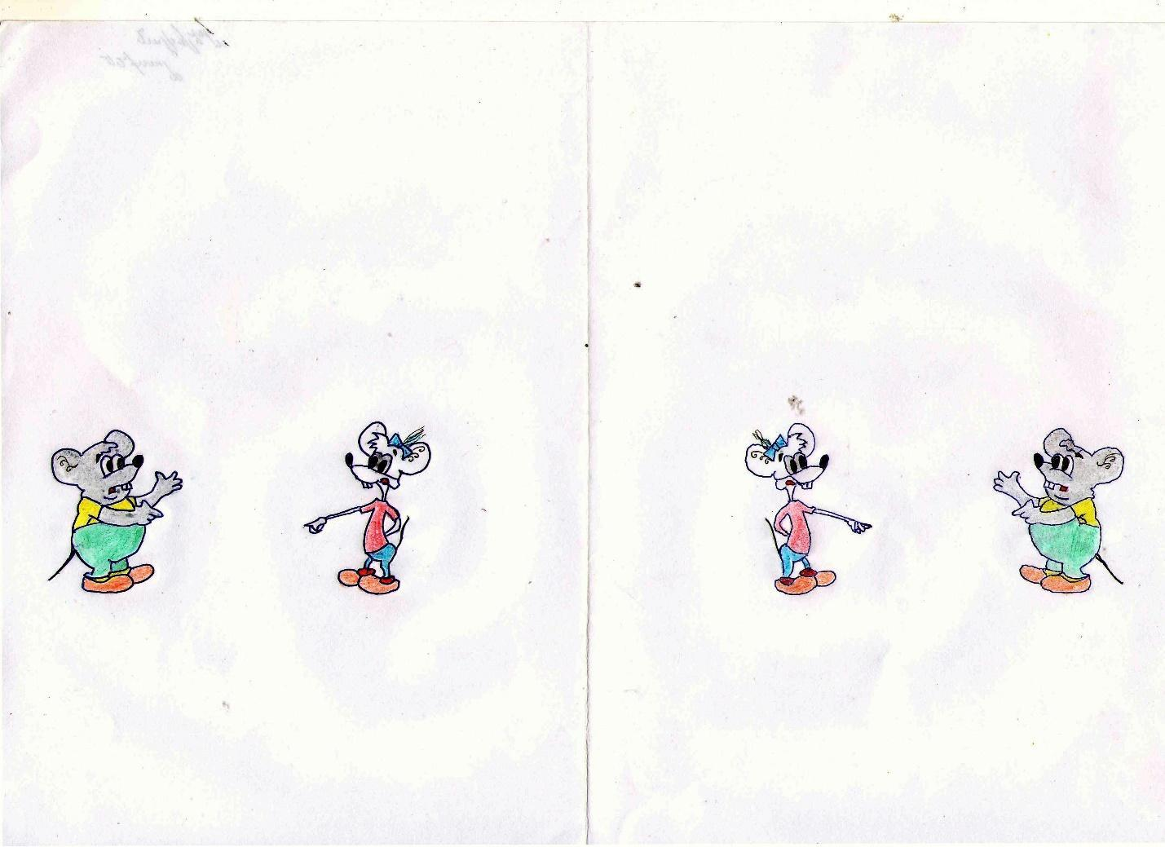
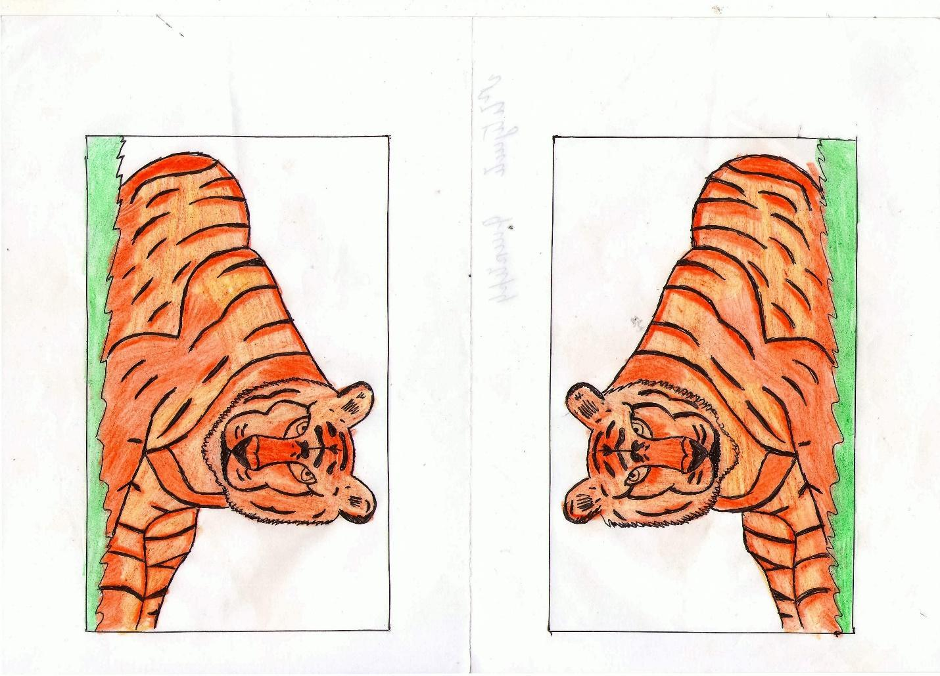
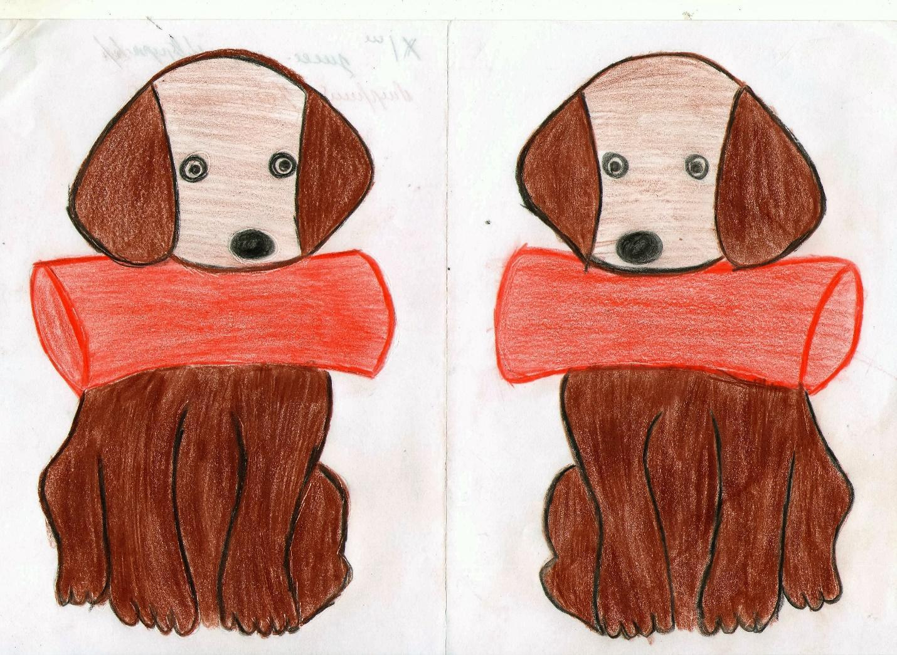
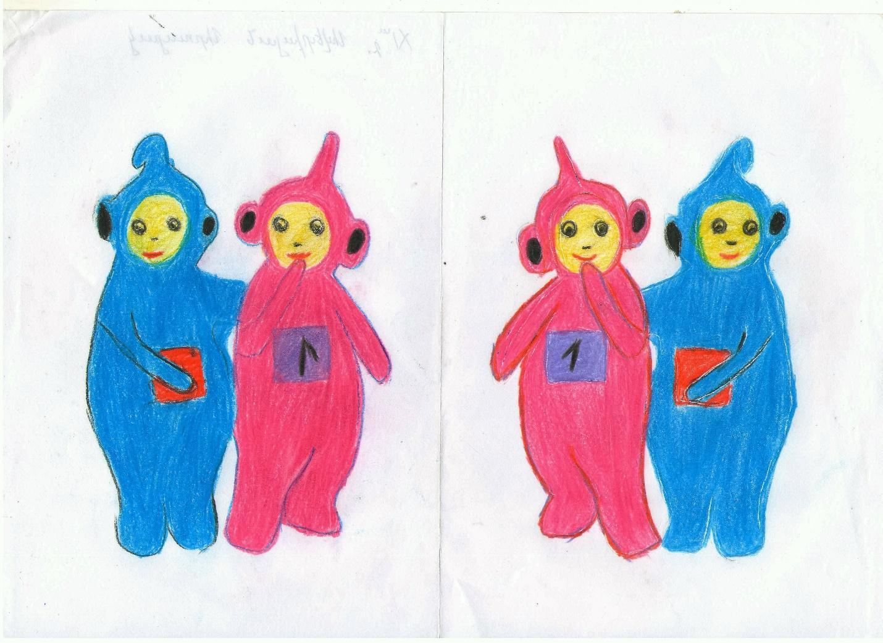
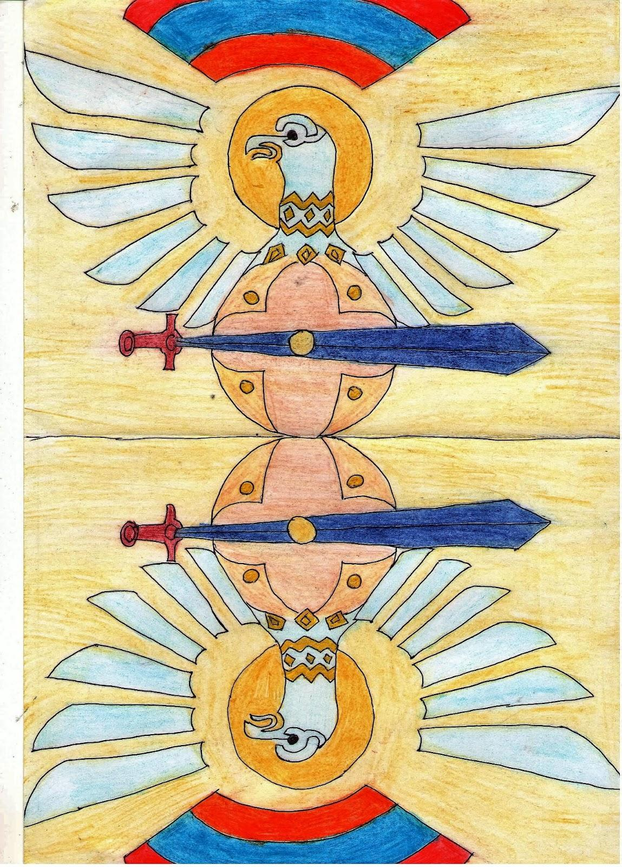

Հարկ է նշել, որ աշակերտները մեծագույն հաճույքով են կատարում նմանատիպ գործնական աշխատանքները։ Դասեին ակտիվ մասնակցություն են ցուցաբերում նաև այն աշակերտները, որոնք սովորաբար պասիվ են դասապրոցեսում։
Անդրադառնանք տարածական այն հինգ մարմիններին, որոնք կոչվում են պլատոնյան և աչքի են ընկնում համաչափությունների մեծ թվով: Սակայն բավական է հետևենք բնության այնպիսի մի հրաշք արարածի, ինչպիսին մեղուն է, և նրա նույքան հրաշք ստեղծագործության՝ մեղրի ստեղծմանը, ապա կտեսնենք, որ գոնե կիրառելիության տեսանկյունից կատարյալի ու իդե ալականի մասին պատկերացումը պետք է որ այլ լինի. Մեղուներն ունեն մաթեմատիկական մեծ ընդունակություններ, որոնք մարդիկ նկատել են դեռևս մեր թվարկության 4-րդ դարում: Իսկապես պետք է լինել հմուտ ճարտարապետ, որպեսզի կարողանան այդպիսի վարպետությամբ կառուցել մեղրահացը՝ կողք կողքի շարված կանոնավոր վեցանիստ պրիզմաներով, մեղրամոմից կառուցված դրանց չափազանց բարակ պատերով. Ընդ որում պետք է նկատի ունենալ, որ այդ վեցանիստ պրիզմաներն էլ պատերի ծախսվելիք մեղրամոմի միևնույն քանակությամբ առկայության դեպքում գրավում են առավելագույն ծավալ և տեղավորում առավելագույն քանակությամբ մեղր: Պարզվում է, որ կիրառելիության պրակտիկ և գեղագիտական հնարավորություններով կանոնավոր վեցանկյուն պրիզման գերազանցում է պլատոնյան մարմիններին: Անդրադառնանք նաև գեղեցիկ և կատարյալ ձև ունեցող այնպիսի պատկերների, ինչպիսիք են շրջանը և գունդը. Սրանք արդեն աչքի են ընկնում ինչպես համաչափությունների աննախընթաց առատությամբ, այնպես էլ կիրառելիության մեծ հնարավորություններով, օպտիմալությամբ և կայունությամբ, հանգամանքներ, որոնք գեղագտակա կատարյալի իդեալականի հրաշալի պատճառ են դարձել և օգտագործվել բնության մեջ:
Հավասարումների և անհավասարումների ուսուցման հետ առնչվող նյութը ավանդաբար ունի կիրառական լայն ոլորտ ու հնարավորություններ: Դրա շաղկապումը ուսումնական նյութի հետ ընդլայնում է սովորողի մտահորիզոնը, ձևավորում աշխարհայացքը, ինչը փաստում է զարգացվածության ձևավորման կարևոր գործընթաց և միաժամանակ մաթեմատիկական գեղեցիկի կիրառելիության օբյկտիվ հատկանիշների կիրառություն: Այս թեման մեծ հնարավորություն է ընդձեռում առօրյա կյանքում հանդիպող կիրառական խնդիրների լուծման համար: Խնդիրներ, որոնք վերաբերվում են շարժմանը, լուծույթներին, աշխատանքին, ուղիղ և հակադարձ համեմատություններին և այսպես շարունակ: Իսկ ինչ է հավասարաությունը. Կարող է որևէ մեկն իր կյանքը պատկերացնել առանց հավասարության առնչության: Մեզ անհրաժեշտ բոլոր չափումները, կշռումները, գնումները կատարվում են հավասարության սկզբունքի կիրառությամբ, ավելին՝ մաթեմատիկական հավասարությունն է, որը որպես շինանյութ ծառայում և հնարավոր է դարձնում մաթեմատիկական ողջ ճարտարապետությունը, ինչի հիման վրա էլ ստեղծվում է ժամանակակից գիտությունն ու տեխնիկան՝ ինքնաթիռի թռիչքը, հեռուստահաղորդումը, արբանյակները և այլն:
Սովորողների մտածողության, մտահորիզոնի, աշխարհայացքի զարգացման ևս մեկ հրաշալի առիթ է ստեղծվում կոորդինատական համակարգերի՝ կոորդինատական ուղղի, կորդինատական հարթության և կոորդինատական տարածության դիտարկումը: Հասկացությունների ուսուցման նշված հերթականնությունն արդեն որոշակի միտում ունի իր մեջ: Այս թեման ուսումնասիրելիս կարևոր է կապ ստեղծել հանրահաշվի և երկրաչափության միջև, հատկապես շեշտը դնելով քառակուսային անհավասարումների լուծման երկրաչափական և հանրահաշվական իմաստների վրա: Թեման ուսուցանելու ժամանակ աշակերտների հետաքրքրությունը մեծացնելու համար առաջարկվում է տրված պատկերը տեղադրել կոորդինատային հարթության վրա և գտնել նրա կոորդինատները, ինչպես նաև հակառակը՝ կառուցել պատկերը՝ ունենալով նրա կոորդինատները: Գաղափար է տրվում այն մասին, որ կորդինատային համակարգը աչքի է ընկնում առօրեական կիրառությամբ. Այն հատկապես օգնում է գտնելու մարմնի դիքը հարթության վրա և տարածության մեջ:
Ասվածը պրակտիկ կիրառությւն ունի շախմատում, կինոդահլիճում համապատասխան տեղի կողմնորոշմամբ:
ՄԻՋԱՌԱՐԿԱՅԱԿԱՆ ԿԱՊԵՐ
Իրագործվող կրթական բարեփոխումներն անհրաժեշտաբար պահանջում են ուսուցման ավանդական մոտեցումների վերանայում և նորագույն տեխնոլոգիաների կիրառման անհրաժեշտություն: Ժամանակակից հանրակրթության նպատակներից մեկը մարդու՝ բնության և հասարակության մասին գիտելիքները կյանքում կիրառելու կարողությունների և հմտությունների ապահովումն է, որը հեշտությամբ կարելի է իրագործել ուսուցման գործընթացում՝ միջառարկայական կապերի կիրառմաբ: Միջառարկայական կապերի գլխավոր խնդիրը բնության և հասաակության մասին գիտելիքների ամբողջական համակարգի ձևավորումն է:
Դիտարկենք ֆիզիկայի և մաթմատիկայի կապը: Այսպես. Անհնար է այս 2 առարկաները պատկերացնել միմյանցից զատ: Ֆիզիկայի ցանկացած առաջադրանք հնարավոր չէ լուծել առանց մաթեմատիկական հաշվարկներ կիրառելու, ասվածի պարզագույն օրինակներ են ճանապարհի, մարմնի խտության, աշխատանքի և նմանատիպ այլ խնդիրների լուծումը:
Անքակտելի կապի մեջ են նաև մաթեմատիկան և երաժշտությունը: Սրանք երկուսն էլ ակտիվանում են ուղեղի նույն շրջանները: Մասնավորապես հետազոտողները արձանագրել են, որ գլխուղեղի ճակատային կեղևը նույն ակտիվությունն է ունենում մաթեմատիկական խնդիրներ լուծելու ժամանակ, ինչպես երաժշտություն լսելիս: Եթե դիպչենք ձգված լարին, ապա բարեհունչ ձայն կլսվի: Տարբեր երկարություն ունեցող լարերը տարբեր տոնայնությամբ ձայներ են արձակում: Եթե միաժամանակ դիպչենք տարբեր երկարության լարերի, ապա նրանց համատեղ հնչումը կարող է լինել ինչպես բարեհունչ, այպես էլ՝ անբարեհունչ: Հին Հունաստանի մեծ փիլիսոփա ևմաթեմատիկոս թվերի հայր Պյութագորասը, ով համոզված էր, որ թվերն են կառավարում երկիրը, առաջիններից էր, ով արտահայտեց այն միտքը, որ երկիրը գնդաձև է և տիեզերքում գտնվում է առանց հենարանի: Նա և իր աշակերտները դեռևս Քրիստոսից առաջ 6-րդ դարում առաջինները հասկացան, որ հնչյունների ներդաշնակությունը կարելի է արտահայտել թվերի միջոցով: Պյութագորասը պարզեց, որ լարի կեսի արձակած ձայնը համահունչ է ամբողջ լարի արձակած ձայնին: Այս ձայներն ունեն տարբեր բարձրություններ, դրանց միջև գտնվող ձայների միջակայքը կոչվում է օգտավա: Նույն կերպ շարունակելով Պյութագորասը հայտնաբերեց ևս 2 բարեհունչ միջակայք՝ կվարտա ¾ և կվինտա՝ 2/3:
ՙ՚Բնությունը գիրք է՝ գրված մաթմատիկայի լեզվով՚՚ - այս միտքը առավել պատկերովոր է դառնում, երբ բության գիքը գրաված է հայերենով ու իր մեջ պարունակում է մաթեմատիկական տարրեր: Մեզանից շատերն անգամ իրենց մտքով չեն կարող անցկացնել, որ մեր լեզուն մաթեմատիկորեն համակարգված լեզու է, համատիեզերական լեզու: Այսպես.ՙ Մաշտոցը ,,Ճանաչել զիմաստություն և զխրատ, իմանալ զբանս հանճարոյ՚՚ նախադասության մեջ կոդավորել է մետաղների մասին գիտությունը, որից օգտվել է հայոց այբուբենի տառերի թվայնացման ժամանակ.
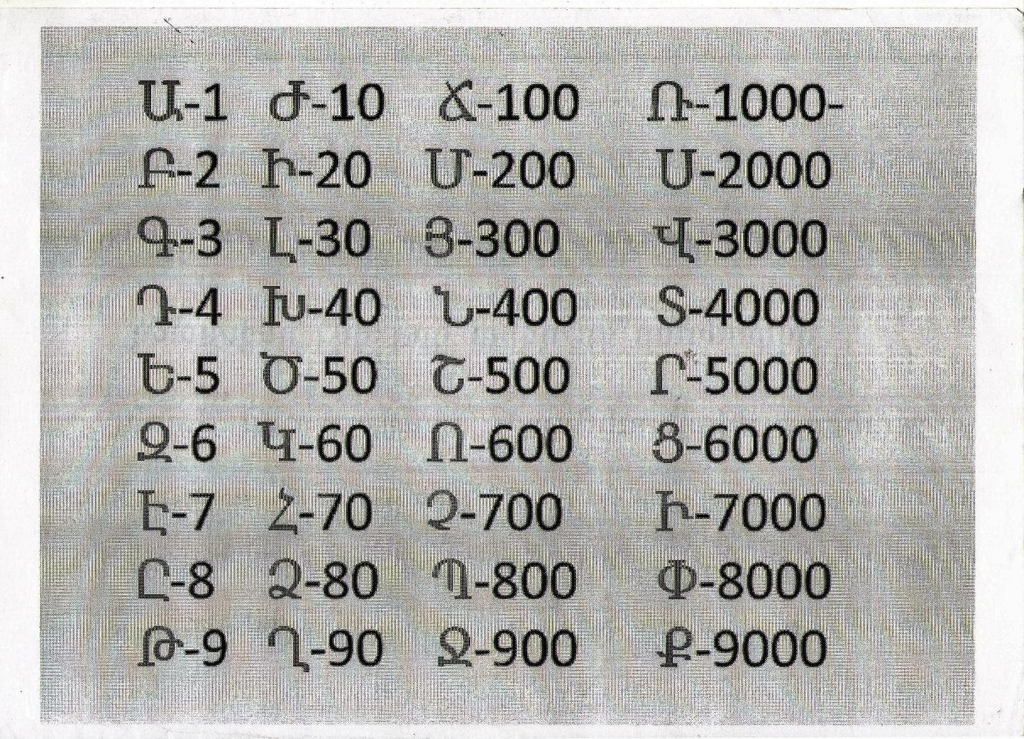

Հայոց այբուբենում Մաշտոցը ներմուծեց 7 ձայնավոր, որոնք, ըստ էության, 7 մոլորակների հնագույն նշաններն էին, իսկ ամեն մի մոլորակին համապատասխանում էր հնագույն ժամանակներում հայտնի մետաղներից մեկը.
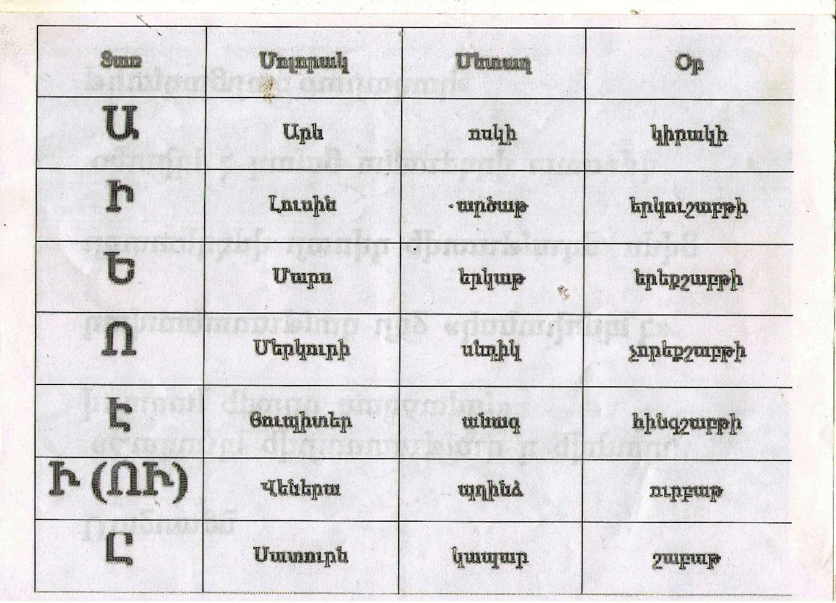
Այբուբենի հավասարակողմ եռանկյունաձև դասավորելու դեպքում 3 անկյուններում հայտնվում են Ա, Ս, Ք տառերը.
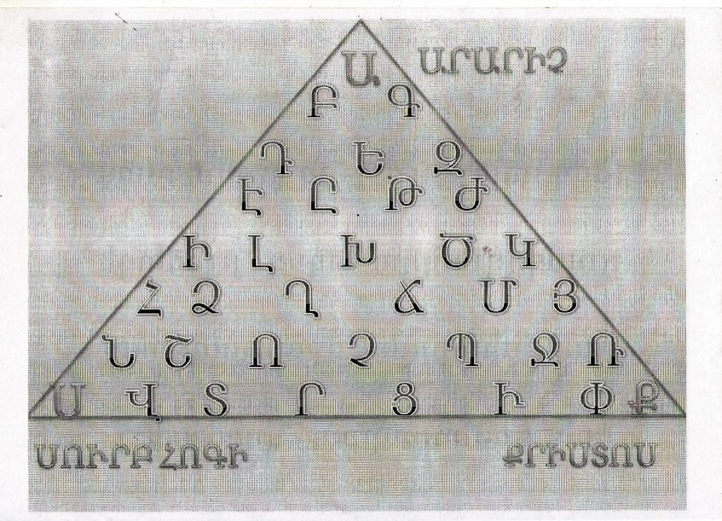
Շեղանկյունաձև դասավորման դեպքում գագաթնային տառերում հայտնվում են Հ, Ա, Յ, Ք տառերը.
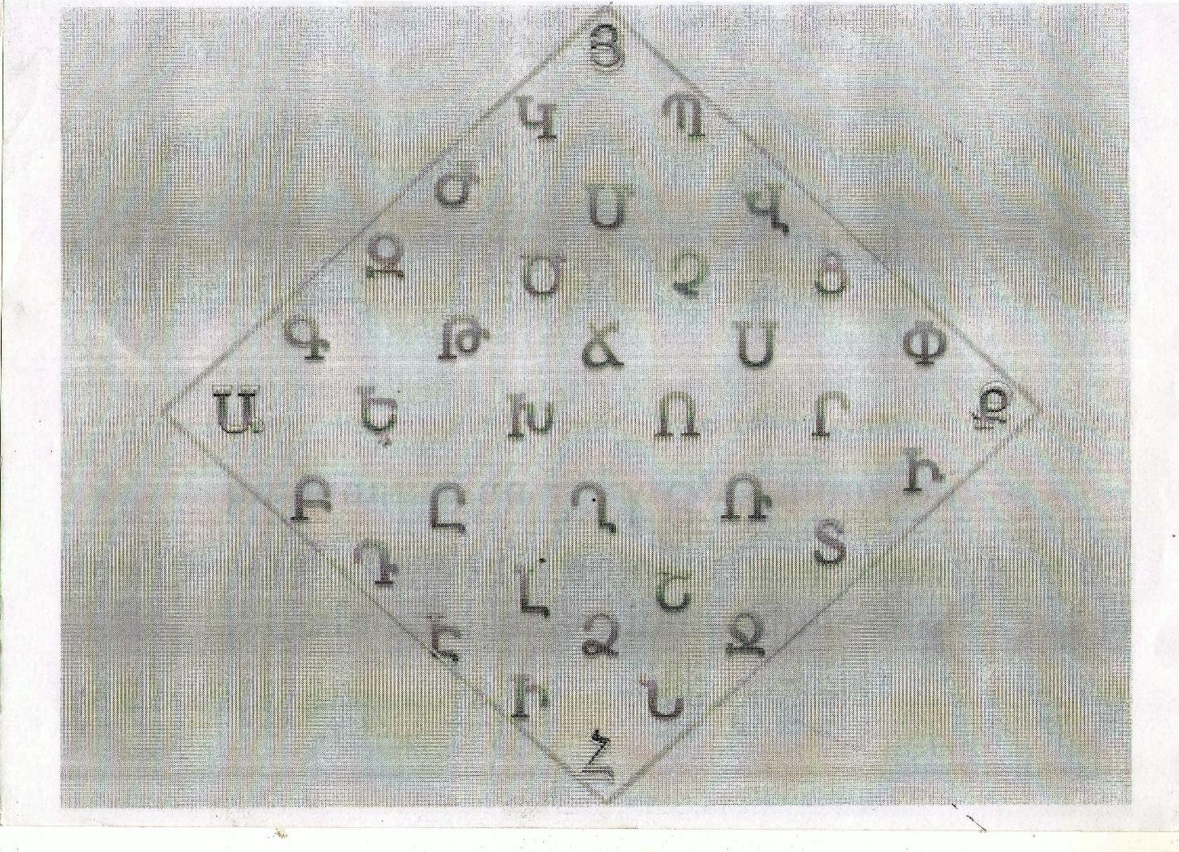

Քառակուսի դասավորման դեպքում գագաթներում հայտնվում են Ա, Զ, Տ, Ք տառերը.
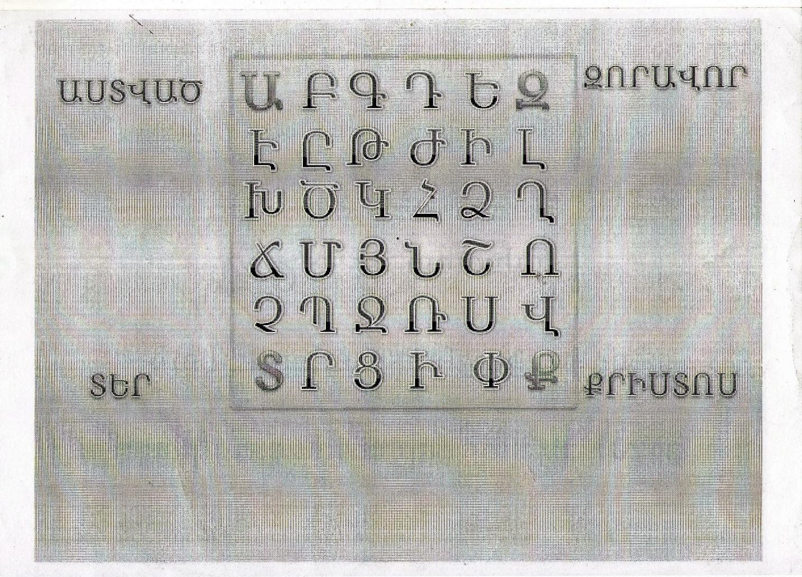
Նշենք, որ վերոնշայալների մասին աշակերտների գիտելիքները ամրապնդելու նպատակով կազմակերպվե է ՙՙԲաց դաս՚՚՝ ՙՙՄաթեմատիկան առօրյա կյանքում՚՚ թեմայով:

Հավելենք նաև, որ մաթեմատիկան միջառարկայական կապեր ունի մնացած բոլոր առարկաների հետ ևս:

ԱՆԴՐԱԴԱՐՁ
Միջոցառումից հետո այնքան մեծացավ երեխաների հետաքրքրությունը հատկապես Պյութագորասի թեորեմի նկատմամբ, որ նրանք տարբեր աղբյուրներից փնտրեցին և գտան թեորեմի շատ հետաքրքիր ապացույցներ, որոնք ներկայացնում եմ ստորև

Ապացույց 1
Ուղղանկյուն եռանկյան համար Պյութագորասի թեորեմի ամենապարզ ապացույցի համար անհրաժեշտ է սահմանել իդեալական պայմաններ՝ թող եռանկյունը լինի ոչ միայն ուղղանկյուն, այլև հավասարաչափ: Հիմքեր կան ենթադրելու, որ դա այնպիսի եռանկյունի է, որն ի սկզբանե դիտարկվել է հին մաթեմատիկոսների կողմից:
Հայտարարություն «Ուղղանկյուն եռանկյան հիպոթենուսի վրա կառուցված քառակուսին հավասար է նրա ոտքերի վրա կառուցված քառակուսիների գումարին»կարելի է նկարազարդել հետևյալ գծանկարով.
Նայեք հավասարաչափ ուղղանկյուն ABC-ին. AC հիպոթենուսի վրա կարող եք կառուցել չորս եռանկյուններից բաղկացած քառակուսի, որը հավասար է սկզբնական ABC-ին: Իսկ քառակուսու վրա կառուցված AB և BC ոտքերի վրա, որոնցից յուրաքանչյուրը պարունակում է երկու նմանատիպ եռանկյունիներ։
Ի դեպ, այս գծանկարը հիմք է հանդիսացել Պյութագորասի թեորեմին նվիրված բազմաթիվ անեկդոտների ու մուլտֆիլմերի։ Թերևս ամենահայտնին է «Պյութագորասյան շալվարները բոլոր ուղղություններով հավասար են»:
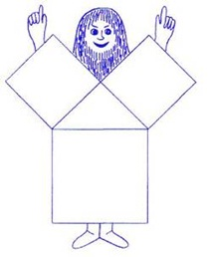

Ապացույց 2
Այս մեթոդը համատեղում է հանրահաշիվը և երկրաչափությունը և կարող է դիտվել որպես մաթեմատիկոս Բհասկարիի հին հնդկական ապացույցի տարբերակ:
Կառուցեք կողմերով ուղղանկյուն եռանկյուն ա, բ և գ(նկ. 1): Այնուհետև կառուցեք երկու քառակուսի, որոնց կողմերը հավասար են երկու ոտքերի երկարությունների գումարին. (ա+բ). Քառակուսիներից յուրաքանչյուրում կազմեք կոնստրուկցիաներ, ինչպես 2-րդ և 3-րդ նկարներում:
Առաջին քառակուսու վրա կառուցեք չորս նույն եռանկյունները, ինչպես նկար 1-ում: Արդյունքում ստացվում է երկու քառակուսի` մեկը a կողմով, երկրորդը` կողմով: բ.
Երկրորդ քառակուսու վրա չորս կառուցված նմանատիպ եռանկյուններ կազմում են հիպոթենուսին հավասար կողմ ունեցող քառակուսի գ.
Նկար 2-ում կառուցված քառակուսիների մակերեսների գումարը հավասար է այն քառակուսու մակերեսին, որը մենք կառուցել ենք նկար 3-ում c կողմով: Սա հեշտությամբ կարելի է հաստատել՝ հաշվելով նկ. 2 ըստ բանաձևի. Իսկ գծագրված քառակուսու մակերեսը Նկար 3-ում. հանելով քառակուսու մեջ ներգծված չորս հավասար ուղղանկյուն եռանկյունների մակերեսները մի կողմ ունեցող մեծ քառակուսու տարածքից։ (ա+բ).
Այս ամենը թողնելով` մենք ունենք. a 2 + b 2 \u003d (a + b) 2 - 2ab. Ընդարձակեք փակագծերը, կատարեք բոլոր անհրաժեշտ հանրահաշվական հաշվարկները և ստացեք դա a 2 + b 2 = a 2 + b 2. Միևնույն ժամանակ, Նկ.3-ում մակագրվածի տարածքը: քառակուսին կարելի է հաշվարկել նաև ավանդական բանաձևով S=c2. Նրանք. a2+b2=c2Դուք ապացուցել եք Պյութագորասի թեորեմը։
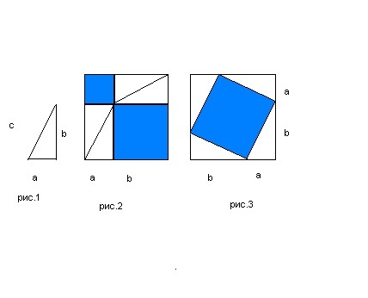

Ապացույց 3
Նույն հին հնդկական ապացույցը նկարագրված է 12-րդ դարում «Գիտելիքի թագը» տրակտատում («Սիդհանտա Շիրոմանի»), և որպես հիմնական փաստարկ հեղինակը օգտագործում է կոչը՝ ուղղված ուսանողների մաթեմատիկական տաղանդներին և դիտորդական կարողություններին: հետևորդներ. «Նայեք»:
Բայց մենք ավելի մանրամասն կվերլուծենք այս ապացույցը.
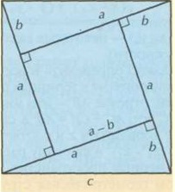
Քառակուսու ներսում կառուցեք չորս ուղղանկյուն եռանկյունիներ, ինչպես նշված է գծագրում: Նշվում է մեծ քառակուսու կողմը, որը նաև հիպոթենուս է -ից. Եկեք կոչենք եռանկյան ոտքերը բայցԵվ բ. Ըստ գծագրի՝ ներքին քառակուսու կողմն է (ա-բ).
Օգտագործեք քառակուսի մակերեսի բանաձևը S=c2հաշվարկել արտաքին հրապարակի մակերեսը. Եվ միևնույն ժամանակ, հաշվարկեք նույն արժեքը՝ ավելացնելով ներքին քառակուսու մակերեսը և բոլոր չորս ուղղանկյուն եռանկյունների մակերեսները. (ա-բ) 2 2+4*1\2*ա*բ.
Դուք կարող եք օգտագործել երկու տարբերակները՝ քառակուսու մակերեսը հաշվարկելու համար, որպեսզի համոզվեք, որ դրանք տալիս են նույն արդյունքը: Եվ դա ձեզ իրավունք է տալիս գրել դա c 2 =(a-b) 2 +4*1\2*a*b. Լուծման արդյունքում կստանաք Պյութագորասի թեորեմի բանաձևը c2=a2+b2. Թեորեմն ապացուցված է.

Ապացույց 4
Այս հետաքրքիր հնագույն չինական ապացույցը կոչվում է «Հարսնացուի աթոռ»՝ աթոռանման կերպարի պատճառով, որը բխում է բոլոր կոնստրուկցիաներից.
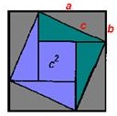
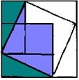
Այն օգտագործում է նկարը, որը մենք արդեն տեսել ենք Նկար 3-ում երկրորդ ապացույցում: Իսկ c կողմով ներքին քառակուսին կառուցված է այնպես, ինչպես վերը բերված հին հնդկական ապացույցում։
Եթե ​​Նկար 1-ի գծագրից մտովի կտրեք երկու կանաչ ուղղանկյուն եռանկյունիներ, դրանք տեղափոխեք քառակուսու հակառակ կողմերը c կողմով և հիպոթենուսները կցեք յասամանագույն եռանկյունիների հիպոթենուսներին, ապա կստանաք մի պատկեր, որը կոչվում է «հարսնացու»: աթոռ» (նկ. 2): Պարզության համար դուք կարող եք նույնը անել թղթե քառակուսիների և եռանկյունների հետ: Դուք կտեսնեք, որ «հարսի աթոռը» ձևավորվում է երկու քառակուսիներով բև մեծ՝ կողքով ա.
Այս կոնստրուկցիաները հին չինացի մաթեմատիկոսներին և նրանց հետևող մեզ թույլ տվեցին գալ այն եզրակացության, որ c2=a2+b2.

Ապացույց 5
Սա երկրաչափության վրա հիմնված Պյութագորասի թեորեմի լուծում գտնելու ևս մեկ միջոց է: Այն կոչվում է Գարֆիլդի մեթոդ:
Կառուցեք ուղղանկյուն եռանկյուն ABC. Մենք պետք է դա ապացուցենք BC 2 \u003d AC 2 + AB 2.
Դա անելու համար շարունակեք ոտքը ACև կառուցել հատված CD, որը հավասար է ոտքին ԱԲ. Ստորին ուղղահայաց ՀԱՅՏԱՐԱՐՈՒԹՅՈՒՆԲաժին ED. Հատվածներ EDԵվ ACհավասար են. միացրեք կետերը ԵԵվ IN, Ինչպես նաեւ ԵԵվ ԻՑև ստացեք ստորև նկարի պես նկար.
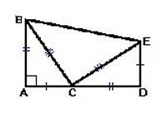
Աշտարակը ապացուցելու համար մենք կրկին դիմում ենք այն մեթոդին, որը մենք արդեն փորձարկել ենք. մենք երկու եղանակով գտնում ենք ստացված գործչի մակերեսը և հավասարեցնում արտահայտությունները միմյանց:
Գտեք բազմանկյունի մակերեսը ՄԱՀՃԱԿԱԼկարելի է անել՝ գումարելով այն կազմող երեք եռանկյունների մակերեսները։ Եվ նրանցից մեկը ERU, ոչ միայն ուղղանկյուն է, այլեւ հավասարաչափ։ Չմոռանանք նաև դա AB=CD, AC=EDԵվ մ.թ.ա.=մ.թ.ա- սա մեզ թույլ կտա պարզեցնել ձայնագրությունը և չծանրաբեռնել այն: Այսպիսով, S ABED \u003d 2 * 1/2 (AB * AC) + 1 / 2BC 2.
Միաժամանակ ակնհայտ է, որ ՄԱՀՃԱԿԱԼ trapezoid է: Հետևաբար, մենք հաշվարկում ենք դրա տարածքը բանաձևով. SABED=(DE+AB)*1/2AD. Մեր հաշվարկների համար ավելի հարմար և պարզ է հատվածը ներկայացնելը ՀԱՅՏԱՐԱՐՈՒԹՅՈՒՆորպես հատվածների գումար ACԵվ CD.
Եկեք գրենք թվի մակերեսը հաշվարկելու երկու եղանակը՝ նրանց միջև հավասար նշան դնելով. AB*AC+1/2BC 2 =(DE+AB)*1/2(AC+CD). Մենք օգտագործում ենք մեզ արդեն հայտնի և վերը նկարագրված հատվածների հավասարությունը՝ նշման աջ կողմը պարզեցնելու համար. AB*AC+1/2BC 2 =1/2(AB+AC) 2. Եվ հիմա մենք բացում ենք փակագծերը և փոխակերպում հավասարությունը. AB*AC+1/2BC 2 =1/2AC 2 +2*1/2(AB*AC)+1/2AB 2. Ավարտելով բոլոր վերափոխումները, մենք ստանում ենք հենց այն, ինչ մեզ անհրաժեշտ է. BC 2 \u003d AC 2 + AB 2. Մենք ապացուցեցինք թեորեմը.
Իհարկե, ապացույցների այս ցանկը հեռու է ամբողջական լինելուց: Պյութագորասի թեորեմը կարելի է ապացուցել նաև վեկտորների, կոմպլեքս թվերի, դիֆերենցիալ հավասարումների, ստերեոմետրիայի և այլնի միջոցով։ Եվ նույնիսկ ֆիզիկոսները. եթե, օրինակ, հեղուկը լցվում է քառակուսի և եռանկյունաձև ծավալների մեջ, որոնք նման են գծագրերում ներկայացվածներին: Հեղուկ լցնելով հնարավոր է ապացուցել տարածքների հավասարությունը և դրա արդյունքում բուն թեորեմը։

Մի քանի խոսք Պյութագորասյան եռյակների մասին
Այս հարցը դպրոցական ծրագրում քիչ է ուսումնասիրված կամ չի ուսումնասիրվում։ Մինչդեռ այն շատ հետաքրքիր է և մեծ նշանակություն ունի երկրաչափության մեջ։ Պյութագորասյան եռյակները օգտագործվում են մաթեմատիկական բազմաթիվ խնդիրներ լուծելու համար։ Դրանց գաղափարը կարող է օգտակար լինել ձեզ հետագա կրթության մեջ:
Այսպիսով, որո՞նք են Պյութագորասի եռյակները: Այսպես կոչված բնական թվեր՝ հավաքված եռյակով, որոնցից երկուսի քառակուսիների գումարը հավասար է երրորդ թվին։
Պյութագորասյան եռյակները կարող են լինել.
- պարզունակ (բոլոր երեք թվերն էլ համեմատաբար պարզ են);
- ոչ պարզունակ (եթե եռակի յուրաքանչյուր թիվը բազմապատկվում է նույն թվով, դուք ստանում եք նոր եռյակ, որը պարզունակ չէ):
Դեռ մեր դարաշրջանից առաջ հին եգիպտացիները հիացած էին Պյութագորասի եռյակների թվի մոլուցքով. առաջադրանքներում նրանք համարում էին 3,4 և 5 միավոր կողմերի ունեցող ուղղանկյուն եռանկյունի: Ի դեպ, ցանկացած եռանկյուն, որի կողմերը հավասար են Պյութագորասի եռյակի թվերին, լռելյայնորեն ուղղանկյուն է:
Պյութագորասյան եռյակների օրինակներ՝ (3, 4, 5), (6, 8, 10), (5, 12, 13), (9, 12, 15), (8, 15, 17), (12, 16, 20) ), (15, 20, 25), (7, 24, 25), (10, 24, 26), (20, 21, 29), (18, 24, 30), (10, 30, 34) ), (21, 28, 35), (12, 35, 37), (15, 36, 39), (24, 32, 40), (9, 40, 41), (27, 36, 45), (14, 48, 50), (30, 40, 50) և այլն:

Թեորեմի գործնական կիրառում
Պյութագորասի թեորեմը կիրառություն է գտնում ոչ միայն մաթեմատիկայի, այլև ճարտարապետության և շինարարության, աստղագիտության և նույնիսկ գրականության մեջ։
Նախ, շինարարության մասին. Պյութագորասի թեորեմը լայնորեն կիրառվում է դրանում բարդության տարբեր մակարդակների խնդիրներում: Օրինակ, նայեք ռոմանական պատուհանին.
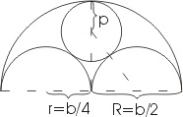
Պատուհանի լայնությունը նշենք որպես բ, ապա մեծ կիսաշրջանի շառավիղը կարելի է նշանակել որպես Ռև արտահայտել միջոցով բ՝ R=b/2. Ավելի փոքր կիսաշրջանների շառավիղը կարող է արտահայտվել նաև արտահայտությամբ բ՝ r=b/4. Այս խնդրի մեջ մեզ հետաքրքրում է պատուհանի ներքին շրջանի շառավիղը (եկեք այն անվանենք էջ).
Պյութագորասի թեորեմը պարզապես հարմար է հաշվարկելու համար Ռ. Դա անելու համար մենք օգտագործում ենք ուղղանկյուն եռանկյուն, որը ցույց է տրված նկարում կետագծով: Եռանկյան հիպոթենուսը բաղկացած է երկու շառավղից. b/4+p. Մեկ ոտքը շառավիղ է բ/4, մեկ այլ բ/2-պ. Օգտագործելով Պյութագորասի թեորեմը, մենք գրում ենք. (b/4+p) 2 =(b/4) 2 +(b/2-p) 2. Հաջորդը, մենք բացում ենք փակագծերը և ստանում b 2 /16+ bp / 2 + p 2 \u003d b 2 / 16 + b 2 / 4-bp + p 2. Եկեք այս արտահայտությունը վերածենք bp/2=b 2 /4-bp. Եվ հետո մենք բոլոր տերմինները բաժանում ենք բ, նմաններին տալիս ենք ստանալու 3/2*p=b/4. Եվ վերջում մենք գտնում ենք, որ p=b/6-ինչը մեզ պետք էր:
Օգտագործելով թեորեմը, դուք կարող եք հաշվարկել գավազանների երկարությունը երկհարկանի տանիքի համար: Որոշեք, թե որքան բարձր է շարժական աշտարակը, որպեսզի ազդանշանը հասնի որոշակի բնակավայր: Եվ նույնիսկ անշեղորեն տեղադրեք տոնածառ քաղաքի հրապարակում: Ինչպես տեսնում եք, այս թեորեմն ապրում է ոչ միայն դասագրքերի էջերում, այլ հաճախ օգտակար է իրական կյանքում:
Ինչ վերաբերում է գրականությանը, ապա Պյութագորասի թեորեմը ոգեշնչել է գրողներին հնագույն ժամանակներից և շարունակում է ոգեշնչել այսօր: Օրինակ, տասնիններորդ դարի գերմանացի գրող Ադելբերտ ֆոն Շամիսոն ոգեշնչվել է նրանից՝ գրել սոնետ.
Ճշմարտության լույսը շուտով չի ցրվի,
Բայց, փայլելով, դժվար թե այն ցրվի
Եվ, ինչպես հազարավոր տարիներ առաջ,
Կասկածներ ու վեճեր չի առաջացնի։
Ամենաիմաստունը, երբ այն դիպչում է աչքին
Ճշմարտության լույս, շնորհակալություն աստվածներին;
Եվ հարյուր ցուլ, դանակահարված, սուտ է,
Բախտավոր Պյութագորասի վերադարձի նվերը.
Այդ ժամանակվանից ցուլերը հուսահատ մռնչում են.
Ընդմիշտ արթնացրեց ցուլ ցեղին
այստեղ նշված իրադարձությունը։
Նրանք կարծում են, որ ժամանակն է
Եվ դարձյալ նրանք կզոհաբերվեն
Մի մեծ թեորեմ.
(թարգմանիչ՝ Վիկտոր Տոպորով)
Իսկ քսաներորդ դարում խորհրդային գրող Եվգենի Վելտիստովն իր «Էլեկտրոնիկայի արկածները» գրքում մի ամբողջ գլուխ նվիրեց Պյութագորասի թեորեմի ապացույցներին։ Եվ երկչափ աշխարհի մասին պատմվածքի կես գլուխ, որը կարող էր գոյություն ունենալ, եթե Պյութագորասի թեորեմը դառնա մեկ աշխարհի հիմնարար օրենքը և նույնիսկ կրոնը: Դրանում ապրելը շատ ավելի հեշտ կլիներ, բայց նաև շատ ավելի ձանձրալի. օրինակ, այնտեղ ոչ ոք չի հասկանում «կլոր» և «փափկամազ» բառերի իմաստը։
Իսկ «Էլեկտրոնիկայի արկածները» գրքում հեղինակը մաթեմատիկայի ուսուցիչ Տարատարայի բերանով ասում է. «Մաթեմատիկայում գլխավորը մտքի շարժումն է, նոր գաղափարները»։ Մտքի այս ստեղծագործական թռիչքն է, որ առաջացնում է Պյութագորասի թեորեմը. իզուր չէ, որ այն ունի այդքան բազմազան ապացույցներ: Այն օգնում է դուրս գալ սովորականից և ծանոթ բաներին նորովի նայել:

Ե Զ Ր Ա Կ Ա Ց ՈՒ Թ Յ ՈՒ Ն
ՙՙՄաթեմատիկան առօրյա կայնքում,, թեմայի դասատվության կազմակերպմանն ու գաղափարական հենքին էր վերաբերում սույն աշխատանքը, որի միջոցով սեղմ տեղեկություններ ներկայացվեցին թեմայի վերաբերյալ: Անդրադարձ կատարվեց մաթեմատիկա գիտությանն ընդհանրապես, դրանում ներառված տարրերին, դրանցով կարգավորվող կանոններին և այս բոլորը աշակերտներին մատուցելու եղանակներին:
Աշխատանքի մեջ անդրադարձ եղավ նաև միջառարկայական կապերին մաթեմատիկայի հետ, որոնց ներկայացումը դասապրոցեսի ընթացքում անհրաժեշտ պայման է՝ աշակերտների աշխարհայացքի ձևավորման և աաշխարհընկալման գործում:
Այսպիսով՝ ներկայացնելով այս ամենը եկանք այն եզրակացության, որ մաթեմատիկա առարկան ոչ միայն թվեր են ու հաշվարկներ, այլ նաև գեղեցիկի բանաձևում և մեզ շրջապատող աշխարհի ու դրանում առկա երևույթների հետաքրքիր մեկնաբանություն: Այսինքն՝ նա ով մաթեմատիկա չգիտի, չի կարող որևէ այլ բան իմանալ և նույնիսկ չի կարող իմանալ իր տգիտությունը:Համոզվեցինք, որ մաթեմատիկայի և գեղագիտական արժեքների միջև կապը շատ սերտ է, որոնք դրսևորում են երաժշտության, նկարչության, քանդակագործության, ճարտարապետության, շինարարության մեջ և գեղագիտական ճաշակ զարգացնող այլ բնագավառներում: Ավելին, մարդկային խոսքի այնպիսի կարևորագույն տարրեր, ինչպիսիք են հիմնավորվածությունը, տրամաբանական խստությունը և ապացուցվածությունը, որոնք համարվում են գիտական գեղեցիկի օբյեկտիվ հատկանիշներ, իրենց լիարժեք դրսևորումը ստանում են հենց մաթեմատիկայում: Գեղագիտական արժեքների ձևավորման հարցը սերտորեն առնչվում է մաթեմատիկայի գիտական և կրթական բովանդակությունների, փոխհարաբերության, մաթեմատիկայի ուսուցման նպատակների, գործառույթների, արդիականացման, մաթեմատիկական օբյեկտների՝ հասկացությունների, թեորեմների, ապացուցումների, խնդիրների ու դրանց լուծման և այլ հիմնախնդիրների հետ:Հետազոտական մեթոդն ունի մի շարք առավելություններ: Այն սովորողների մոտ ավելիլավ է զարգացնում հետազոտական հմտությունները, իրականացվում է տեղեկատվության ինքնուրույն փնտրում: Այս մեթոդով աշխատելիս զարգանում են նաև այնպիսի կարողություններ, ինչպիսիք են ինքնագնահատման կարողությունը, փոխօգնության պատրաստակամությունը, բանավիճելու ունակությունը, սեփական կարծիք արտահայտելու հաստատակամությունն ու խոսքի ձևավորումը: Այն թույլ է տալիս նաև նախագծի կատարման մի քանի հնարավոր տարբերակներից Առանձնացնել ամենաօպտիմալը, կատարվում է դրա հիմնավորում: Հետազոտությունը կարող է բարելավել մարդկանց կենսապայմանը: Աշակերտին պետք է հասանելի դարձնել գործնական աշխատանքի կարևորության կիրառումը կյանքում: Գործնական աշխատանքները կազմակերպելիս չպետք է անտեսել աշակերտի անձնական փորձը: Մաթեմատիկայի գործնական աշխատանքները կարելի է հանձնարարել ինչպես թեմայի ուսուցումը սկսելուց առաջ, այնպես էլ ուսուցումը ավարտելուց հետո: Գործնական աշխատանքները նպաստում են ինքնուրուրույն հանգել հետևությունների:

ՕԳՏԱԳՈՐԾՎԱԾ ԳՐԱԿԱՆՈՒԹՅՈՒՆ
- ՀԱՆՐԱՀԱՇԻՎ – 7-9-րդ դասարաններ
Հեղինակներ՝ Ս. Մ. Նիկոլսկի, Մ.Կ. Պոտապով
Ն.Ն. Ռեշենտիկով, Ա.Վ. Շեվկին
Երևան, Անտարես -2011

2. ՀԱՆՐԱՀԱՇԻՎ – 10-11-րդ դասարաններ
Հեղինակներ՝ Գ.Գ. Գևորգյան, Ա. Ա. Սահակյան
Երևան, Էդիթ Պրինտ _ 2010

3.Երկրաչափություն – 7-9-րդ դասարաններ
Հեղինակներ՝ Լ. Ս. Աթանասյան, Վ. Ֆ. Բուտուզով
Ս.Բ. Կադոմցեվ, Է.Հ. Պոզնյակ, Ի. Ի. Յուդինա
Երևան, Զանգակ – 97 – 2011

4. Երկրաչափություն – 10-12-րդ դասարաններ
Հեղինակներ՝ Ս. Է. Հակոբյան
Երևան, Տիգրան Մեծ – 2009

5.Մաթեմատիկան դպրոցում
Գիտամեթոդական ամսագրեր թիվ 1 -2013թ.

